
Madhuben & Bhanubhai Patel Institute of Technology The Charutar Vidya Mandal (CVM) University
BOOTCAMP
Problem Solving – Data to Decisions: Modern Business Intelligence with Power BI, Databricks & Microsoft Fabric
DATE: 09th October,2026 Friday
Time: 9:00 PM To 4:00 PM

Institute: Madhuben & Bhanubhai Patel Institute of Technology
Venue: B-003, MBIT College
Coordinators: Dr. Pritesh Pandey & Ms. Bhumika Prajapati

Convener: Dr. Kalpesh Jadav (HOD, IT Department)

Objective:
The bootcamp aimed to introduce participants to modern business intelligence and data-driven problem-solving, with a focus on Power BI, Databricks, and Microsoft Fabric. It was designed to help participants understand how data can be transformed into meaningful insights to support informed decisions in contemporary business settings.

Outcome / Benefit:
The bootcamp was intended to strengthen participants’ awareness of modern business intelligence tools and the role of data in decision-making. It highlighted the relevance of Power BI, Databricks, and Microsoft Fabric for organizing, analyzing, and interpreting data in support of practical problem-solving.

Mode of Conduct: Off-line (Talk and Presentation)
Student Coordinator: Princy Prajapati

Report
The Information Technology department from Madhuben & Bhanubhai Patel Institute of Technology (MBIT), The CVM University, organized a bootcamp on “Problem Solving – Data to Decisions: Modern Business Intelligence with Power BI, Databricks & Microsoft Fabric” on 9 October 2026 at the B003–3 Lab. The programme focused on the importance of data-driven problem-solving and modern business intelligence tools.
The session was led by Mr. Ishan Prabhakar Bhatt, Tech Lead at L&T Technology Services (LTTS), Vadodara. The event provided a platform for participants to engage with the topic and learn about the role of Power BI, Databricks, and Microsoft Fabric in turning data into decisions. The supplied photographs show the speaker addressing participants and participants attending the session in the computer laboratory.
The bootcamp supported the institute’s efforts to connect academic learning with current industry practices in data analytics and business intelligence. Attendance figures and detailed participant feedback were not provided in the supplied material and have therefore not been included.

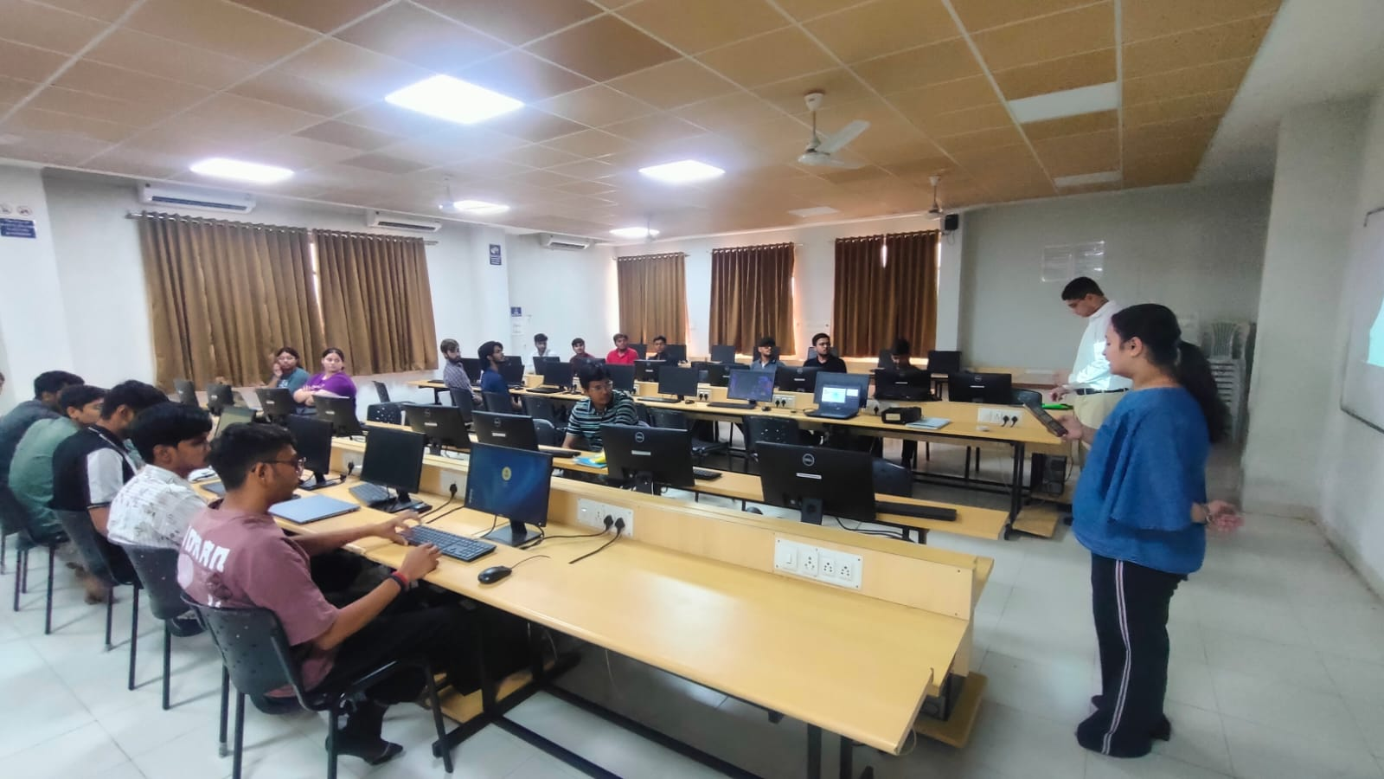

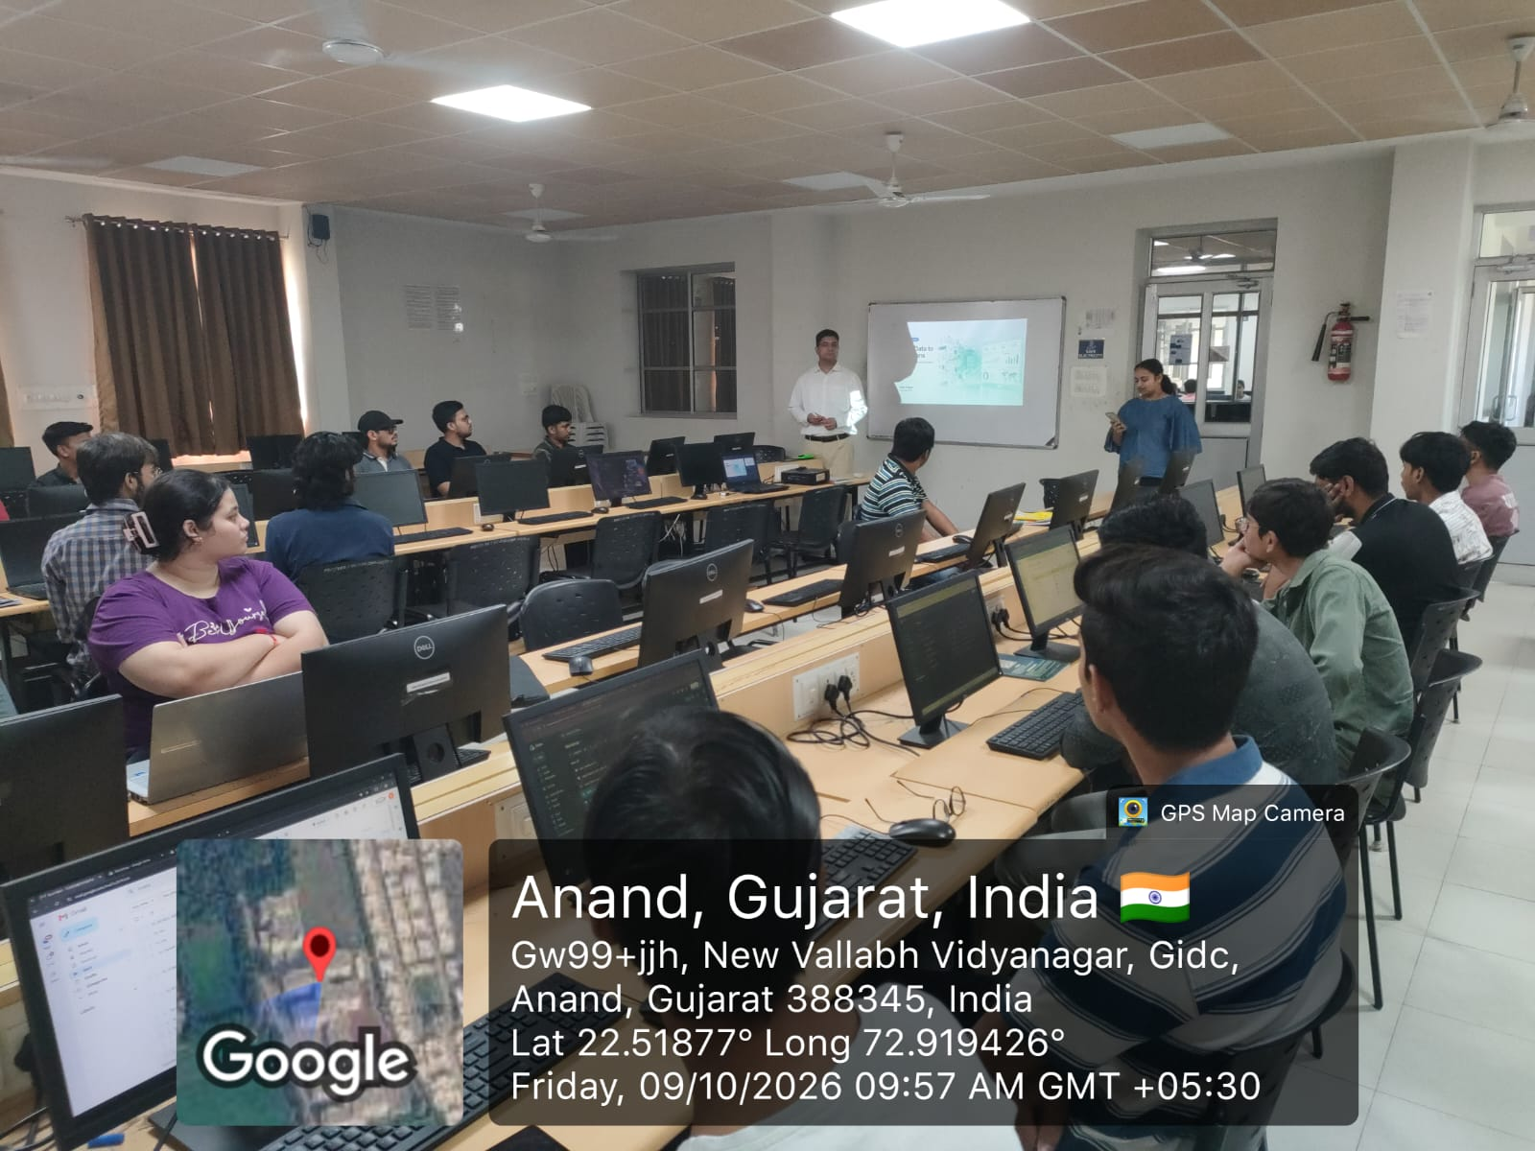

Number of Faculty – 02 Number of Student -40 Total Participations - 42
