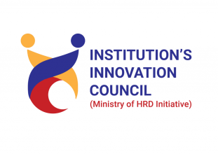
Madhuben & Bhanubhai Patel Institute of Technology The Charutar Vidya Mandal (CVM) University
Title: TECHNICAL SESSION
THE AI DEPENDENCY STARTER PACK
Date: 22-07-2026
Time: 1:30pm to 3:30pm

Institute: Madhuben & Bhanubhai Patel Institute of Technology
Venue: A-202 Auditorium
Faculty Coordinator/s: Prof.Dhruva Mistry
Bridge Course Coordinator: Dr. Shreekant Pathak
Bridge Course Co-coordinator: Ms. Riddhi Sondagar

Objective: The objective of this workshop was to provide students with a clear understanding of the Artificial Intelligence and its tools. The students had hands on technical session on various AI tools for creating prompts, give it to appropriate tools ,deployment for particular website development is also done. The workshop aimed to encourage students to develop AI thinking, adaptability and practical applications required for future challenges.

Outcome / Benefit: The technical session on AI starer pack provided students with practical knowledge of modern artificial intelligence technologies and their applications in software development, data analysis, content generation, and automation. Students gained hands-on exposure to popular AI tools, learned how to use them effectively for coding, debugging, documentation, and project development, and developed an understanding of the ethical and responsible use of AI. The session enhanced their technical skills, productivity, and confidence in leveraging AI tools for academic learning, research, innovation, and future industry applications.

.

Mode of Conduct: Off-line (Talk and Presentation,Hands on)

Student Coordinator:
Manas Choksi,
Mihir Rabari,
Laukik Rajput,
Pari Patel

Report
The Department of Applied Science and Humanities at Madhuben & Bhanubhai Patel Institute of Technology (MBIT) organized a workshop titled “TECHNICAL SESSION on THE AI DEPENDENCY STARTER PACK” on 22nd July 2026 at A-202. The session is conducted by Mr.Karan Mistry and his team.The objective of the session was to familiarize students with the latest AI-powered development platforms and demonstrate how these tools can accelerate software development, improve productivity, and simplify application deployment. The session focused on providing hands-on experience with modern AI tools used for coding, UI design, backend integration, and application deployment.
A technical hands-on session on various AI tools and model uses for required was organized for first year students. The session aimed to introduce participants to next-generation AI-assisted development platforms that enable rapid application development with minimal coding effort. Students actively explored the features of these tools through live demonstrations and practical exercises.
The technical hands-on session successfully introduced for first year students to modern AI-powered development tools, including Lovable AI, Loop Engineering, Vercel, Claude, Anti Gravity IDE, KIRO, and Firebase. Through interactive demonstrations and practical exercises, students gained valuable experience in AI-assisted application development, cloud deployment, backend integration, and intelligent coding practices. The session enhanced their technical knowledge, problem-solving abilities, and confidence in using advanced AI technologies to build efficient and scalable software solutions. It also encouraged students to adopt emerging AI tools responsibly, explore innovative software development practices, and apply these technologies in academic projects, research, internships, hackathons, and future professional careers.

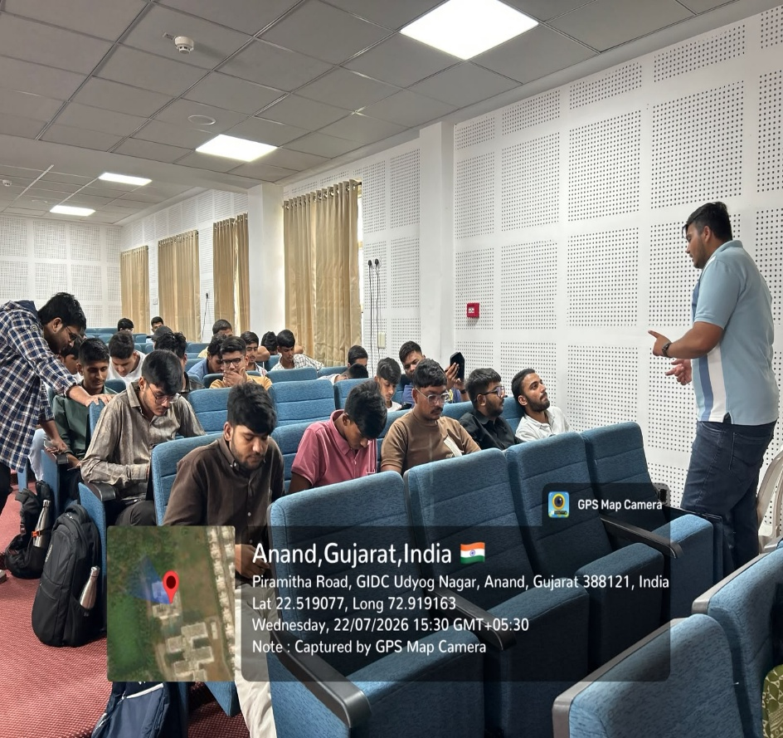
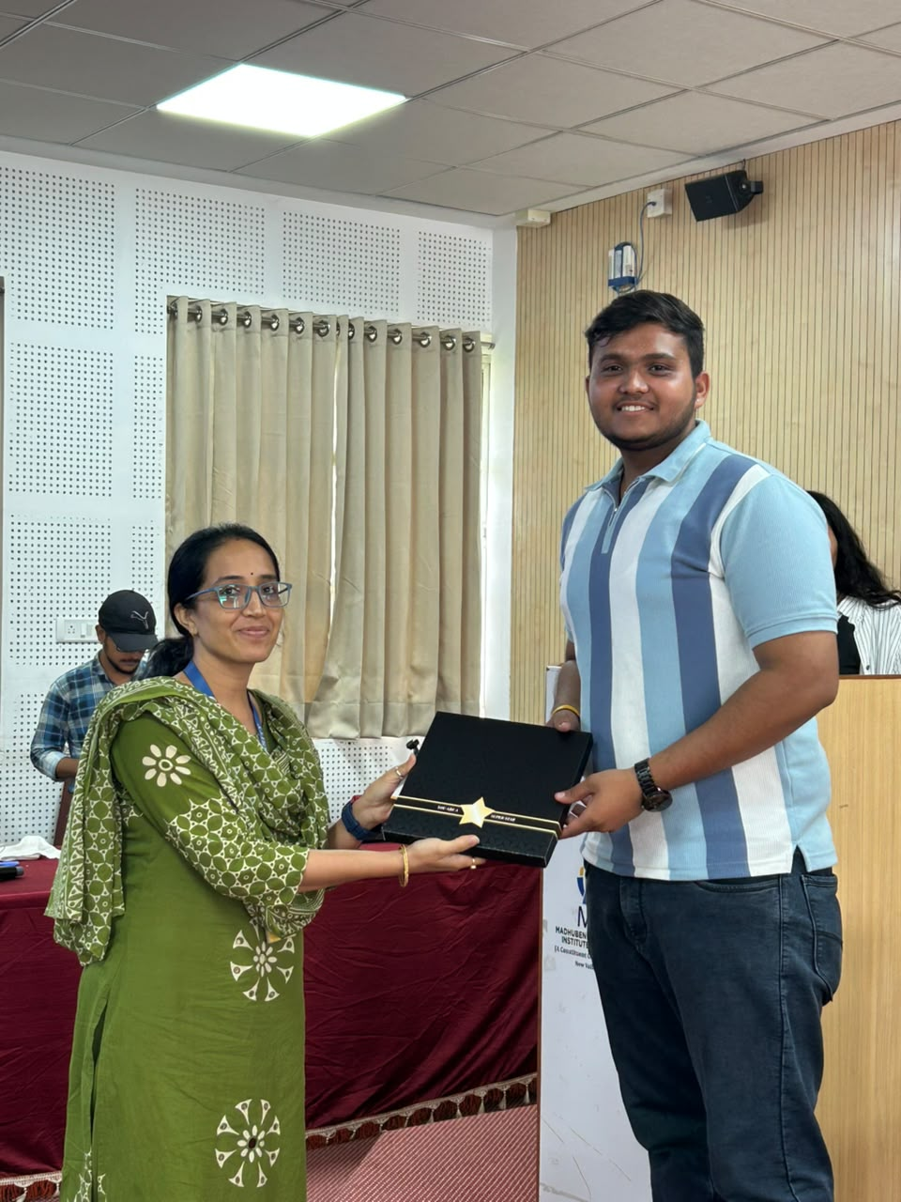

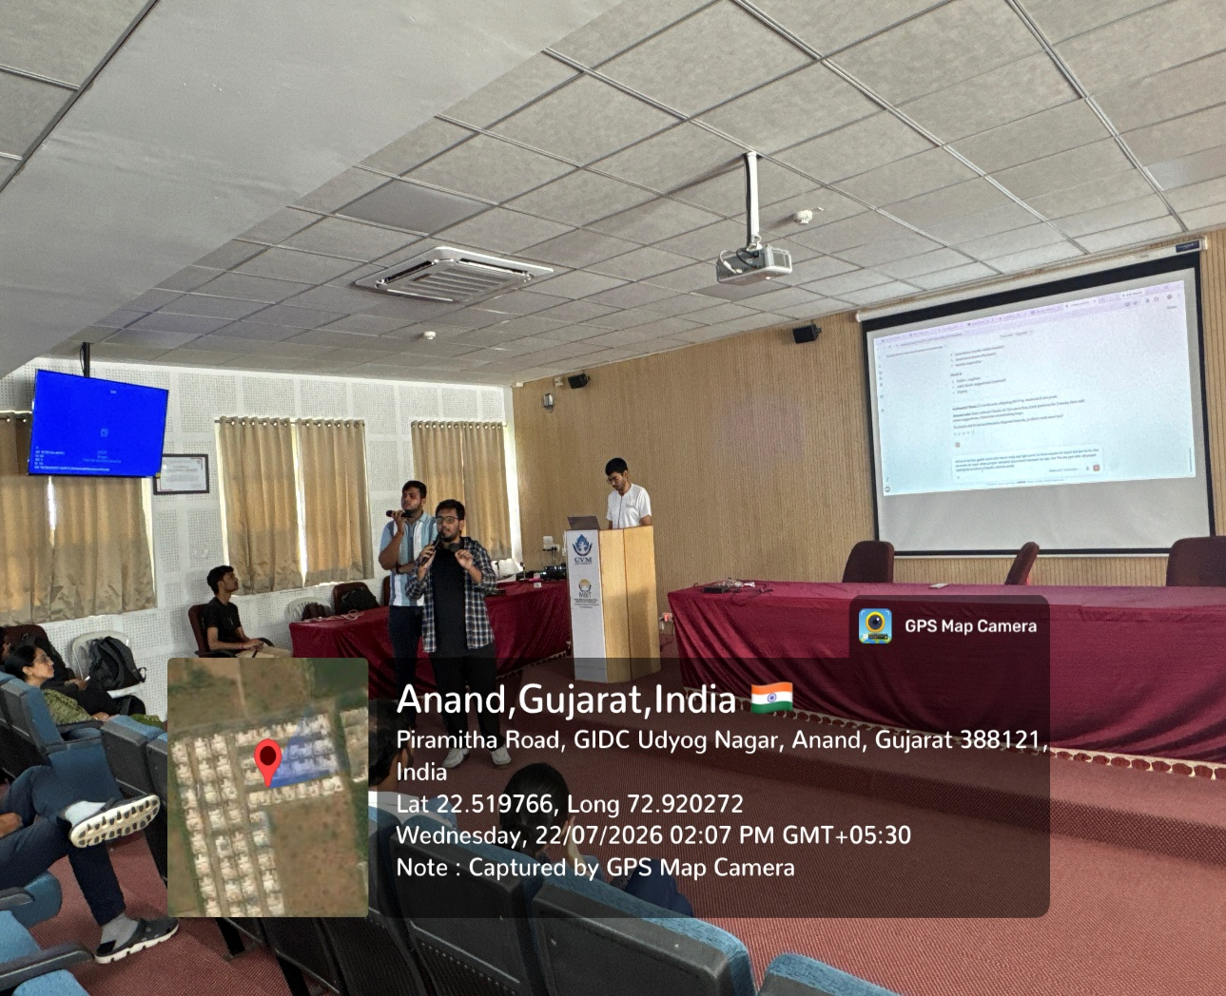

Dr. Shreekant Pathak Assistant Professor, ASH Department & Bridge Course Coordinator | Ms. Riddhi Sondagar  Assistant Professor,  ASH Department & Bridge Course Co-coordinator

Number of Faculty – 2
Number of Student -20+18+35+15+33+25+26=172
Total Participants -172
Photos of Attendance Sheet:
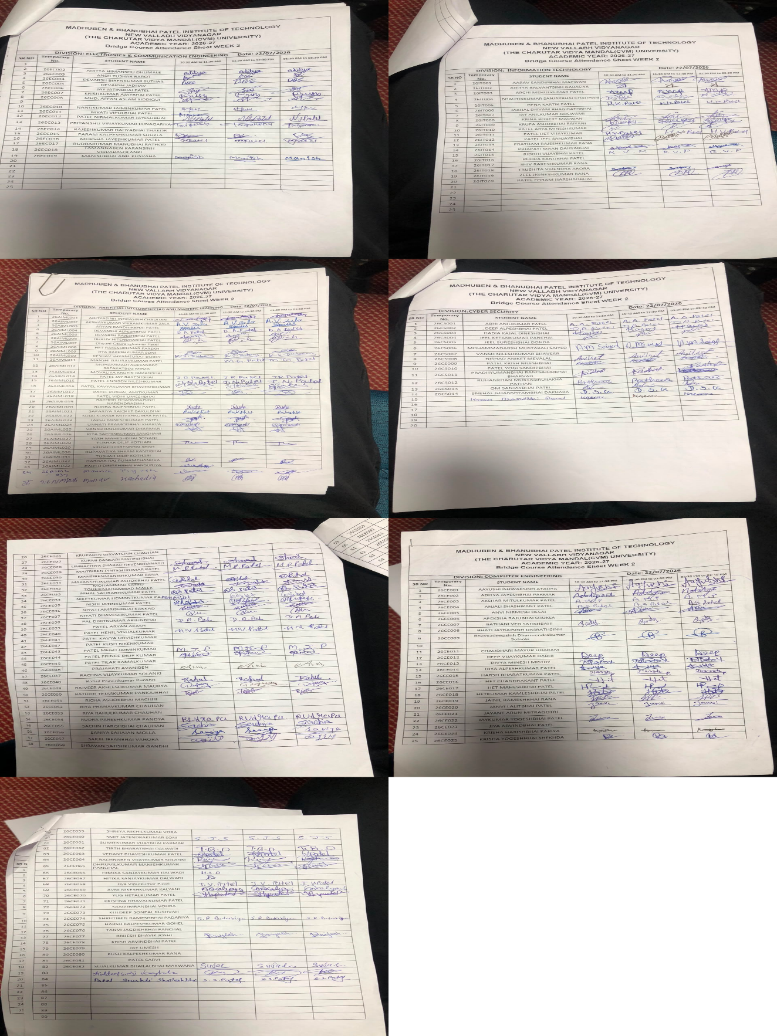

Event Poster:

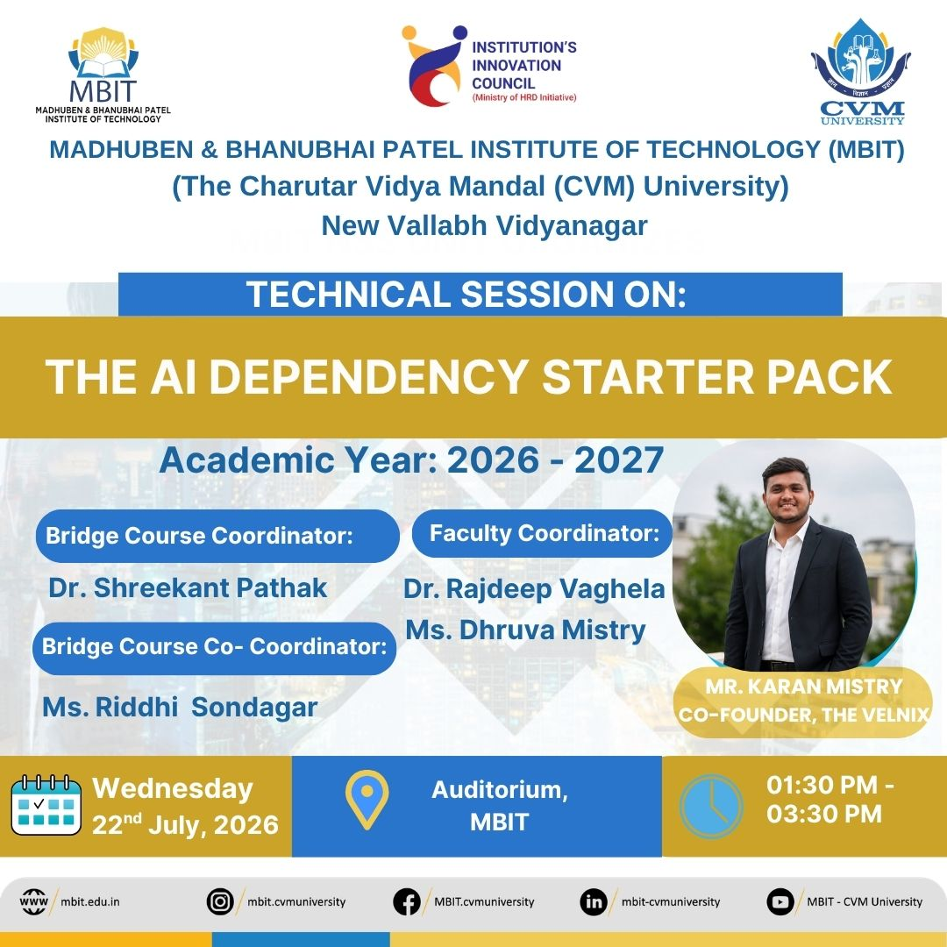

Social media links:

