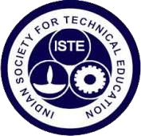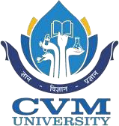

Event Report On
“ISTE Orientation Program for First Year Students”

17th July, 2026

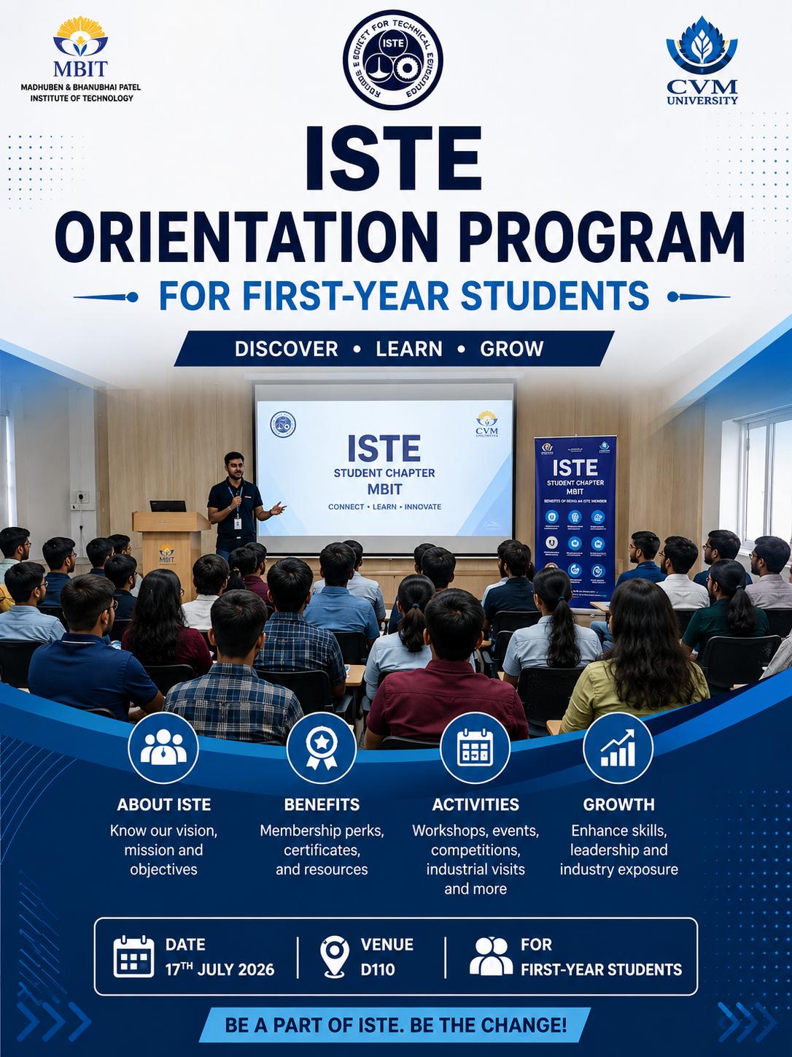

Organized By:-
ISTE STUDENT CHAPTER

MADHUBEN AND BHANUBHAI PATEL INSTITUTE OF TECHNOLOGY

The Charutar Vidya Mandal University(CVM University),

New Vallabh Vidyanagar.

The ISTE Student Chapter of Madhuben & Bhanubhai Patel Institute of Technology (MBIT) successfully organized an Orientation Program for First-Year Students with the objective of introducing newly admitted students to the Indian Society for Technical Education (ISTE), its vision, activities, and the opportunities it provides for overall professional and technical development.
The orientation session aimed to familiarize students with the benefits of becoming an ISTE member and encourage them to actively participate in technical, cultural, and professional development activities organized throughout the academic year. The session also highlighted how ISTE helps students enhance their technical knowledge, leadership skills, teamwork, communication abilities, and industry exposure beyond the classroom.
During the program, the ISTE Student Chapter members presented an overview of the organization, including its mission, objectives, and achievements. Students were introduced to various events regularly conducted under the ISTE banner, such as technical workshops, expert lectures, coding competitions, hackathons, industrial visits, poster-making competitions, seminars, quizzes, project exhibitions, and skill development sessions.
The speakers also explained the advantages of ISTE membership, including participation certificates, networking opportunities with students and professionals, access to technical resources, leadership opportunities within the student chapter, and exposure to emerging technologies through various academic and industrial activities.
The orientation included an interactive question-and-answer session where first-year students enthusiastically clarified their doubts regarding membership registration, event participation, committee structure, and future activities. Their active involvement reflected a positive response toward becoming a part of the ISTE community.
The event concluded with a vote of thanks, encouraging students to actively engage in upcoming ISTE events and make the best use of the opportunities available through the student chapter for their academic, technical, and personal growth.

GLIMPSE OF THE EVENT:-

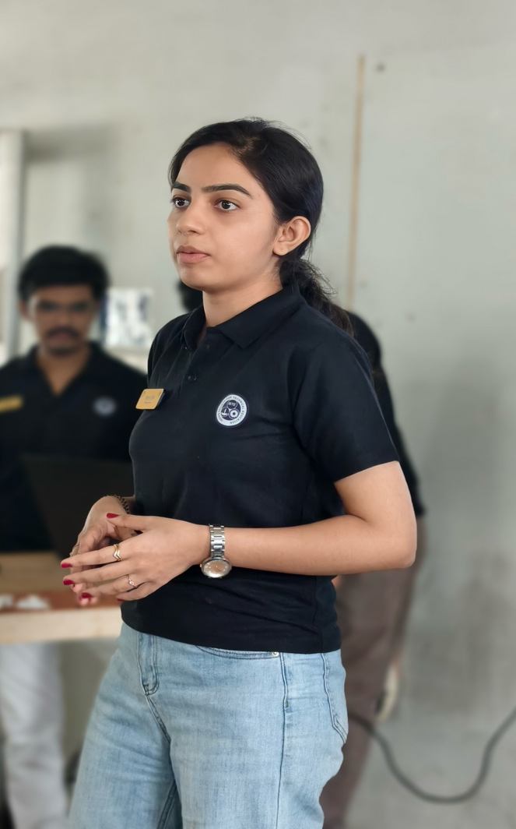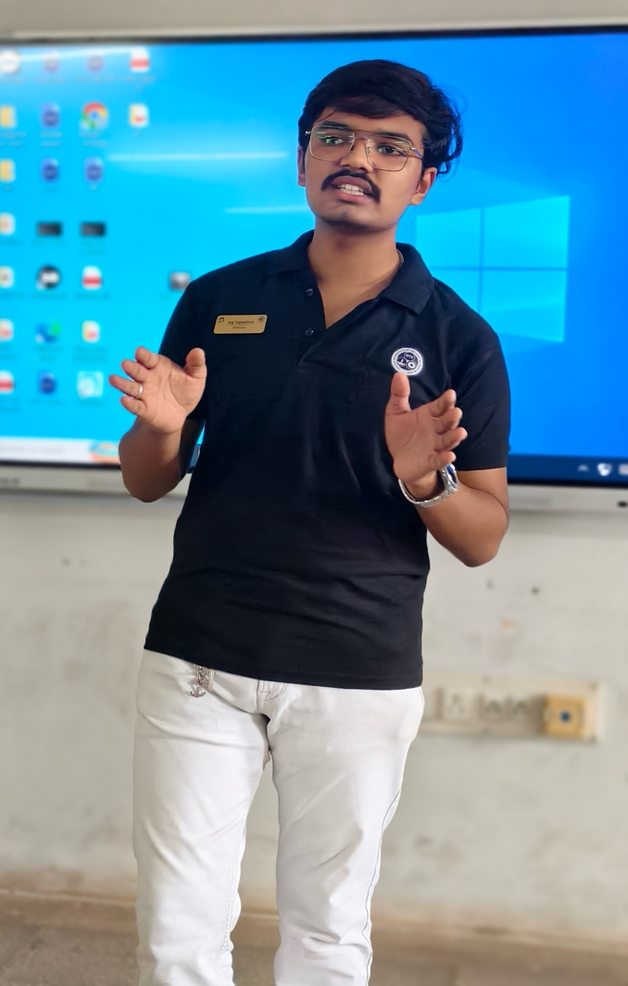

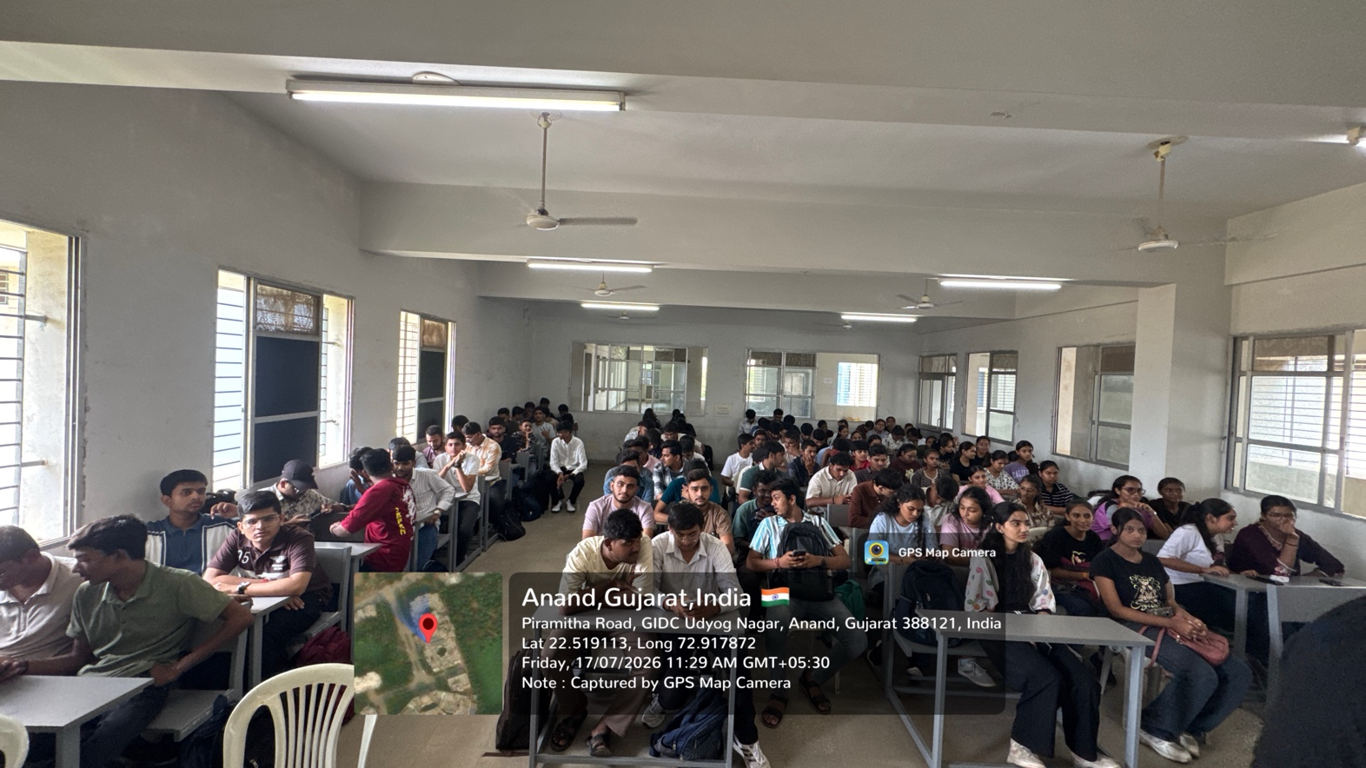

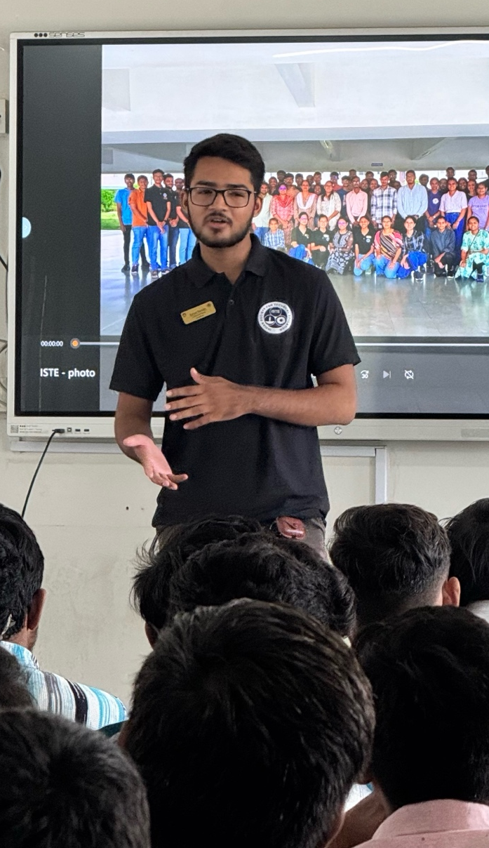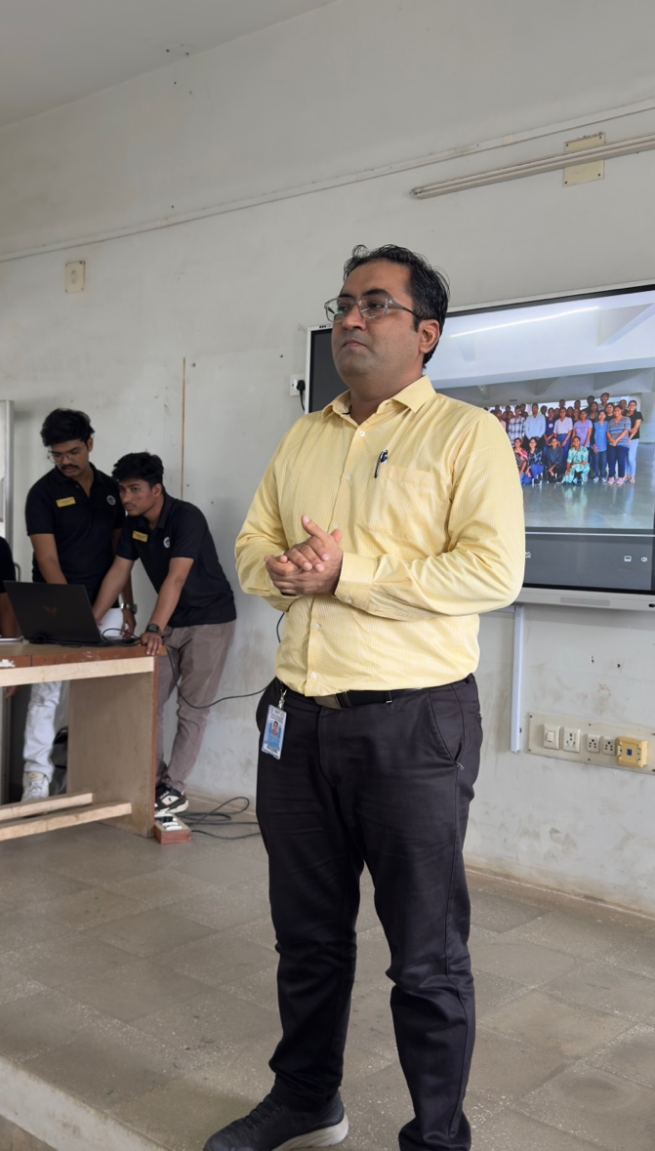

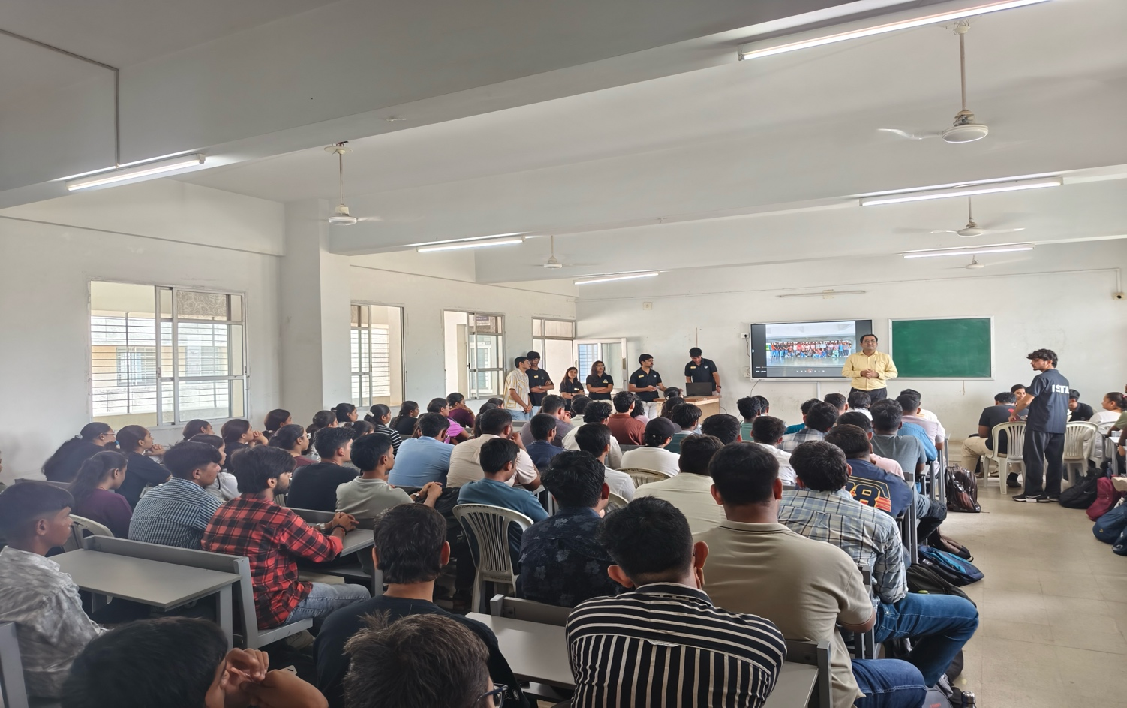
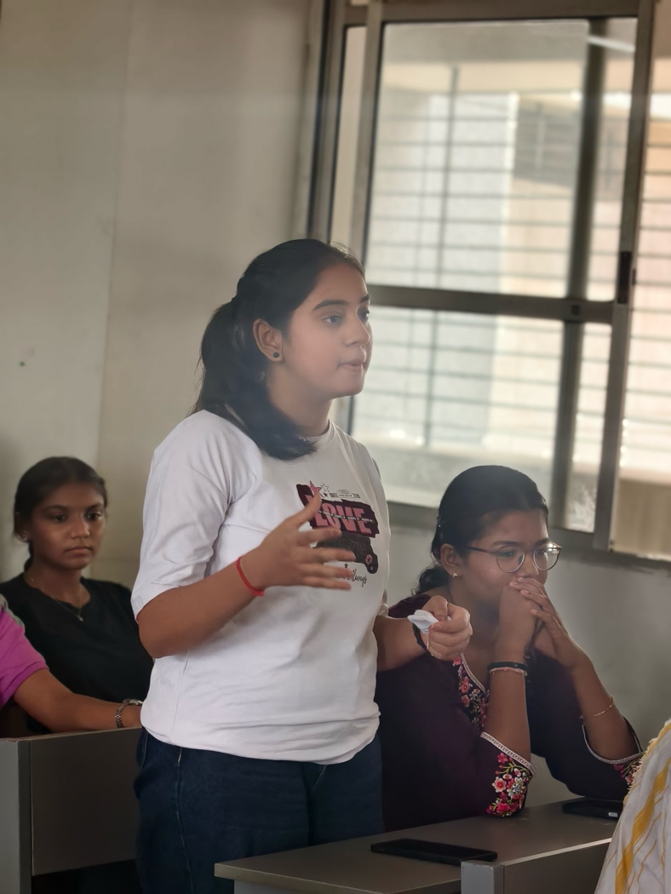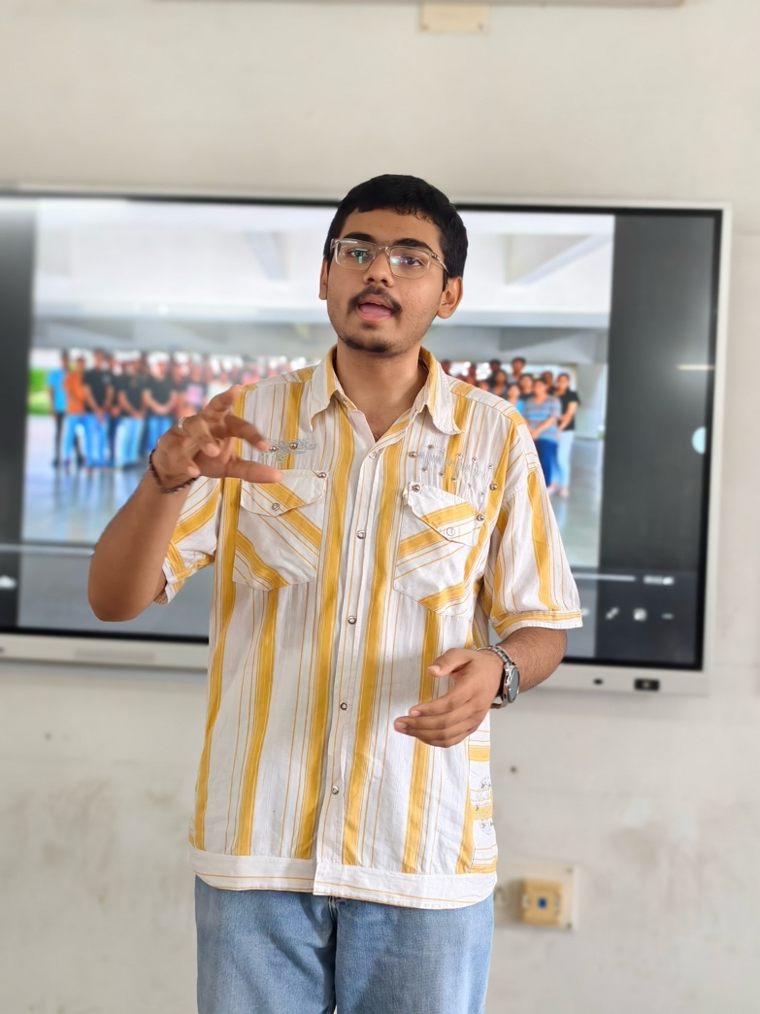

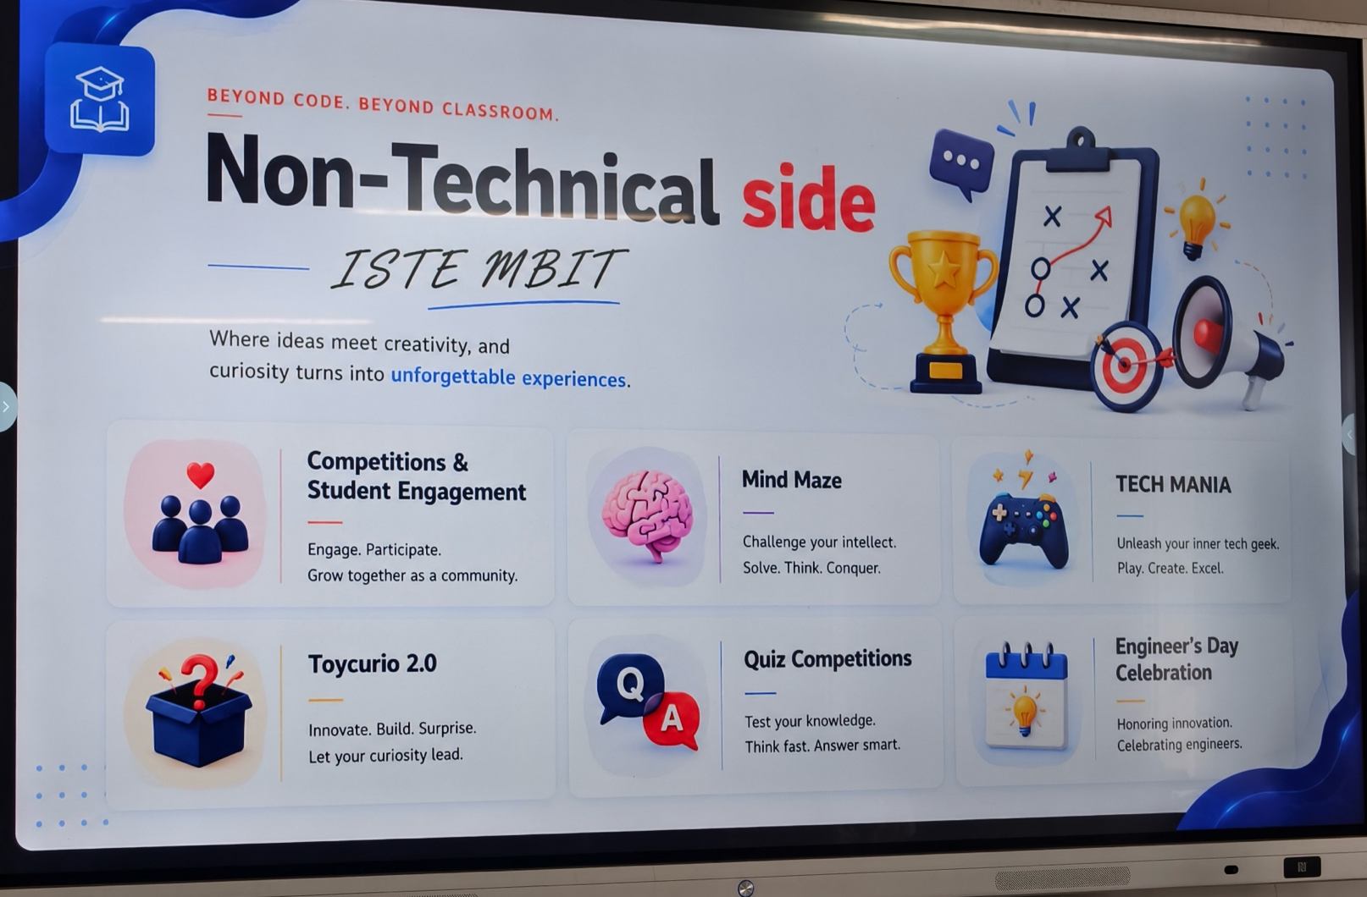
NOTE OF THANKS

We extend our sincere gratitude to our Faculty Coordinator, Mr. Mayur Parmar, for providing constant guidance and encouragement throughout the successful organization of the ISTE Orientation Program. We are equally thankful to all the ISTE core members and volunteers whose dedicated efforts ensured the smooth execution of the event.
A special note of appreciation goes to the enthusiastic first-year students for their active participation and keen interest throughout the session. Their interaction and positive response made the program meaningful and engaging.
Finally, we express our heartfelt gratitude to our respected Principal, faculty members, and CVM University for their continuous support and for providing us with the opportunity to organize such an informative and inspiring event for the students.

