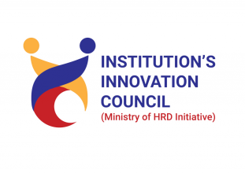
Madhuben & Bhanubhai Patel Institute of Technology

The CharutarVidya Mandal (CVM) University

Fire Extinguisher Demonstration and Fire Safety Awareness
DATE: 15th July, 2026, Wednesday
Time: 01:30 PM To 03:30 PM

Institute: Madhuben & Bhanubhai Patel Institute of Technology
Venue: Canteen Foyer, MBIT College
Coordinators: Ms.Khusbu P Patel, Mr. Jeet Panchal

Convener: : Ms.Khusbu P Patel (NSS Progamme Officer)

Objective:
The objective of the Fire Extinguisher Demonstration and Fire Safety Awareness Program was to educate students and staff about fire prevention, emergency response procedures, and the safe use of fire extinguishers. The program aimed to enhance awareness of fire safety practices, encourage preparedness during emergencies, and promote a culture of safety and responsibility within the institute community.

Outcome/Benefit:
The Fire Extinguisher Demonstration successfully enhanced participants' awareness of fire safety practices and emergency response procedures. Through expert guidance and practical demonstrations, students and staff acquired valuable skills for preventing and managing fire-related emergencies, thereby promoting a safer and more prepared campus community.

Mode of Conduct: Off-line(Demostration)
Student Coordinator: Sujal Parmar, Manas Choksi ,NSS Team Members

Report
NSS Committee of Madhuben and Bhanubhai Patel Institute of Technology, the Charutar Vidya Mandal (CVM) University, New V. V. Nagar organized a Fire Extinguisher Demonstration on July 15th, 2026, at 01:30 pm under the Bridge Course activity.
This event aimed to educate staff and students on crucial measures to prevent and respond to potential fire hazards. Organized, the event aimed to enhance public awareness and promote proactive safety practices.
The session covered fundamental fire safety principles, including the importance of smoke alarms, emergency evacuation plans, and proper usage of firefighting equipment. A live demonstration illustrated the correct handling of fire extinguishers and highlighted common mistakes to avoid accidents.
Participants actively engaged in interactive discussions, sharing personal experiences and concerns related to fire safety. The event emphasized the significance of early detection through smoke alarms and the swift implementation of evacuation plans.
Notable speakers from the local fire department Mr. Jayminbhaikumar Talpada, Fire Safety Officer provided valuable insights into recent fire incidents and shared statistics to underscore the urgency of fire safety education. Attendees left with practical knowledge and a heightened sense of responsibility towards fire prevention in their homes and workplaces.
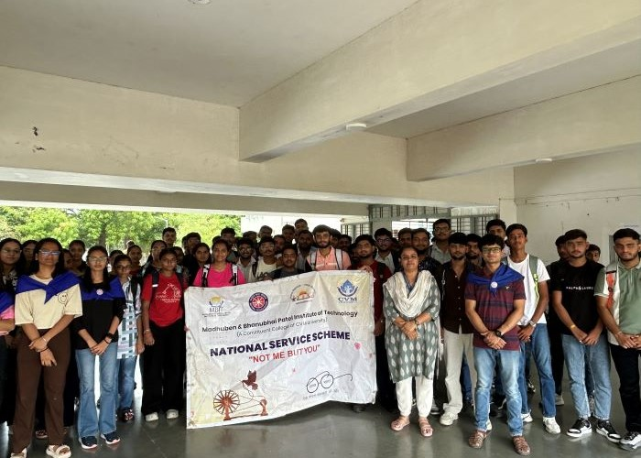
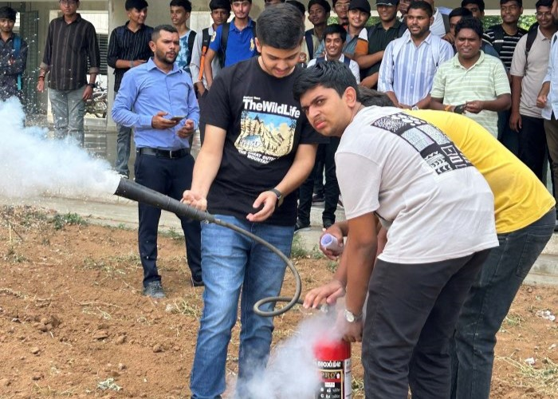
In conclusion, the fire safety awareness event effectively disseminated crucial information, fostering a safer community through increased awareness and preparedness. Ongoing efforts in educating the public about fire safety remain essential to minimize risks and protect lives and property.

Dr. Shreekant Pathak  Assistant Professor, ASH Department  Bridge Course Coordinator | Ms. Riddhi Sondagar  Assistant Professor, ASH Department & Bridge Course Co-coordinator

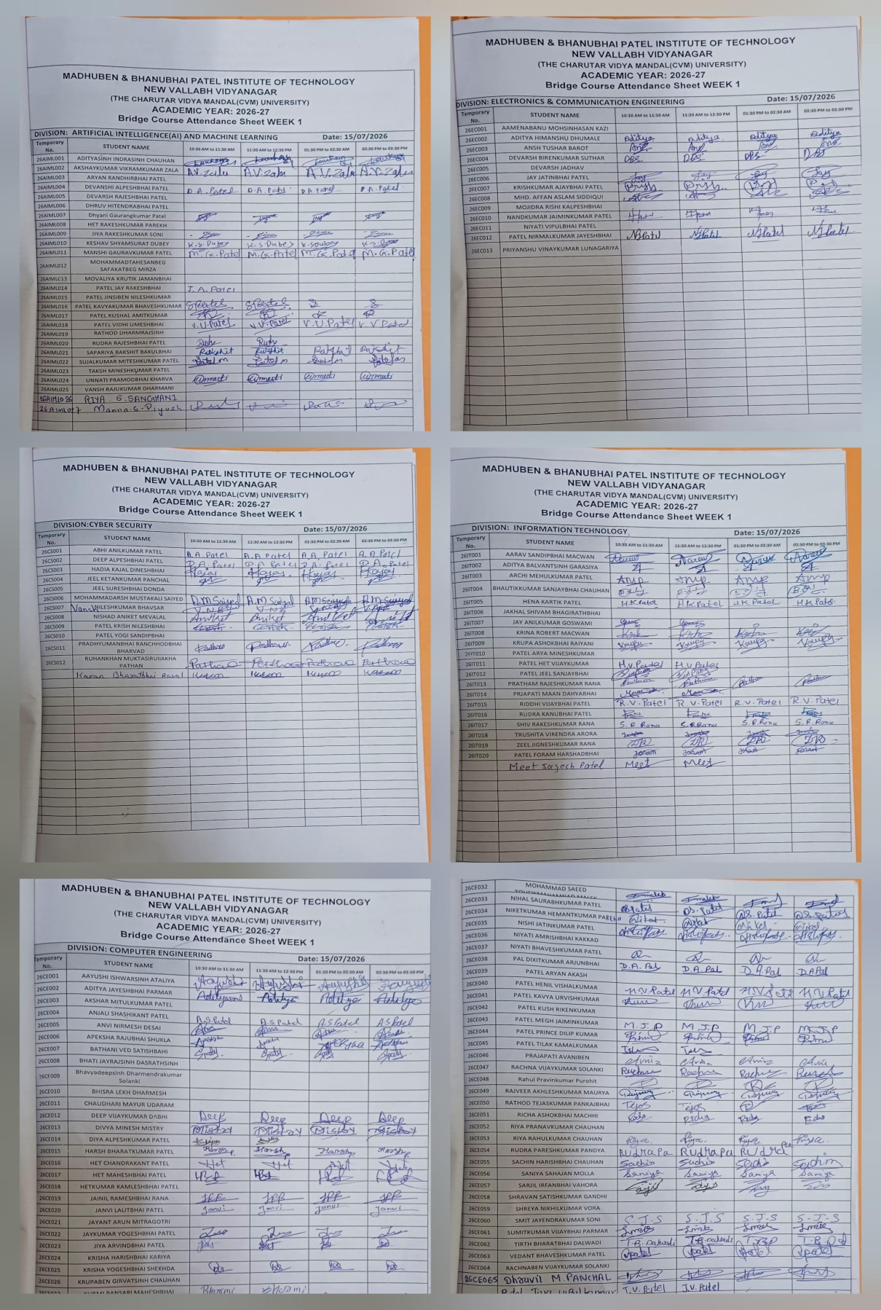
Number of Faculty–03 Number of Student–91 Total Participations- 9
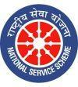
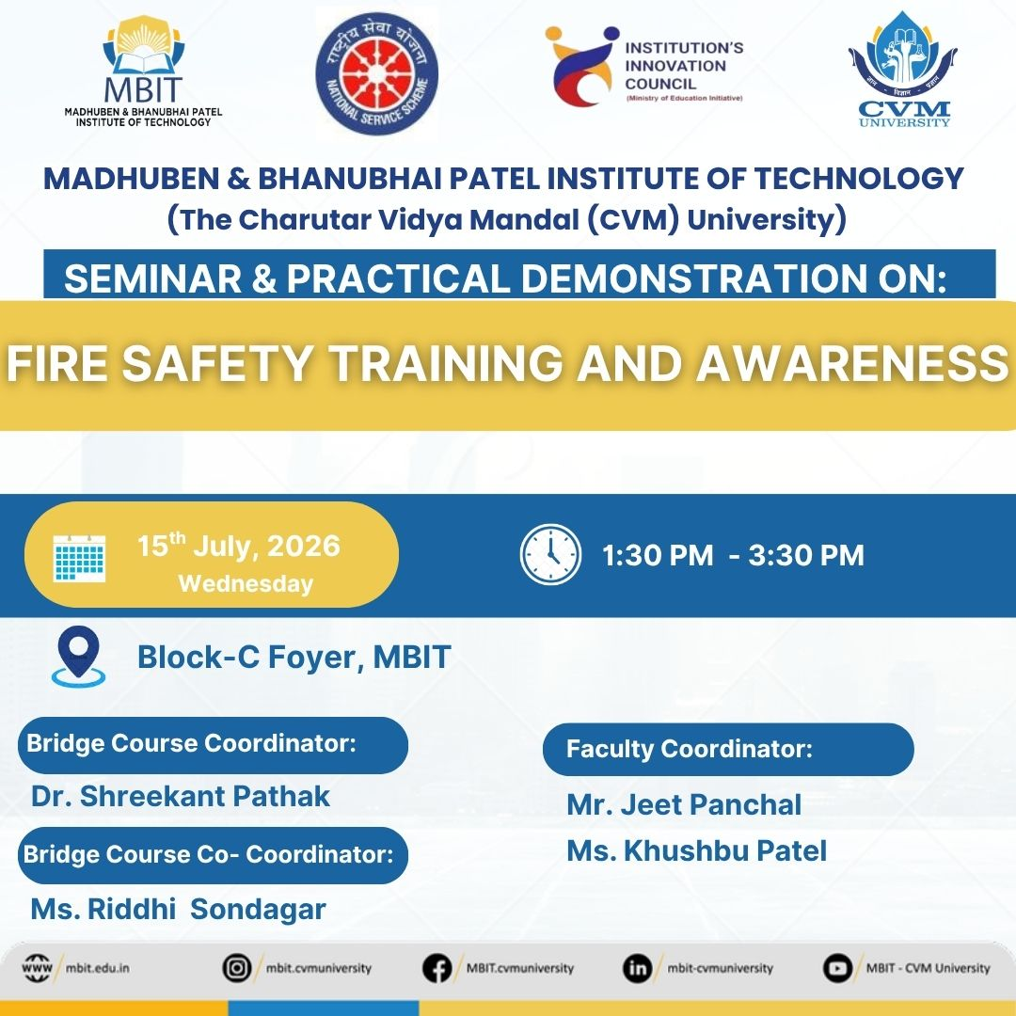

Social Media Link: https://www.instagram.com/p/Da2AdtZDwmS/?img_index=2&igsh=MXZ3OTlpbWN4eGpjNg==

https://www.facebook.com/share/p/1aPHss9Rk3/’

