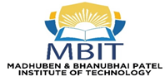 | 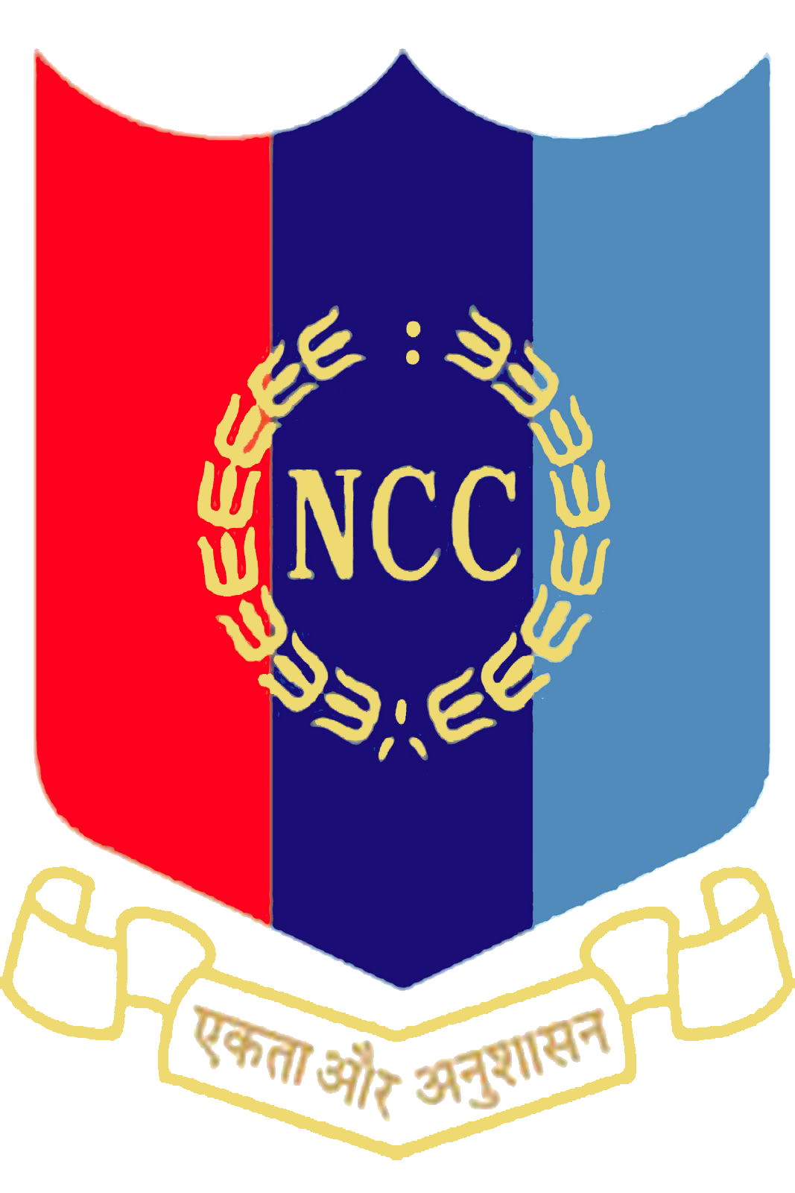 | 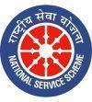 | 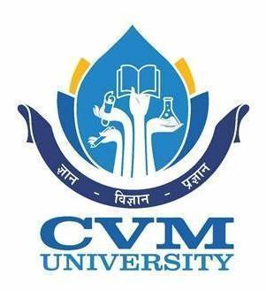
Event Report
Republic Day celebration
At MBIT on 26th January 2026

DATE: January 26th, 2026
VENUE: A-block, MBIT
Time: 8:15 am
Report by: Ms. Khusbu P Patel
NSS Programme officer: Ms. Khusbu P Patel

MBIT proudly celebrated the 77th Republic Day on January 26th, 2026, at the Administrative Block under the theme “Vande Mataram & Atma Nirbhar Bharat.” The program was organized with the objective of instilling national pride, constitutional values, and awareness about self-reliance among students.
The celebration began with the hoisting of the National Flag by the Honourable Principal, Prof. (Dr.) Maulika Patel Madam, followed by the National Anthem, marking respect for the Constitution and the unity of the nation. After the flag hoisting, the Principal Madam addressed the gathering, highlighting the significance of Republic Day, the values enshrined in the Constitution, and the responsibility of youth in nation-building.
As part of the program, an NSS volunteer and NCC cadet Mr. Sujal Parmar delivered a speech on “Vande Mataram,” emphasizing patriotism, unity, and sacrifice for the motherland. This was followed by a patriotic song by Misti Patel, NSS volunteer, which created a sense of pride and emotional connection among the audience. Another NSS student volunteer Ms. Bhargavi Modi delivered a speech on “Atma Nirbhar Bharat,” focusing on the vision of a self-reliant India and the role of students in achieving sustainable national development.
The program concluded with a vote of thanks, acknowledging the support and guidance of the Principal, faculty members, and student participants. A group photograph was taken to commemorate the occasion, followed by sweet distribution among the participants.

