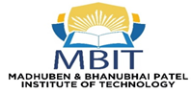 | 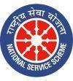 | 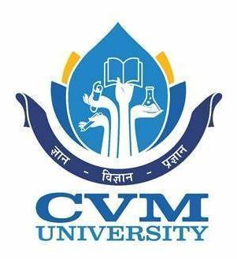
Event Report
Unity March Sardar@150

Date: 26 November 2025
Theme: Sardar @150 – Ek Bharat, Aatma Nirbhar Bharat
Organized by: NSS Unit, MBIT – CVM University
Report by: Ms. Khusbu P Patel
Programme officer: Ms. Khusbu P Patel

The NSS Unit of Madhuben & Bhanubhai Patel Institute of Technology (MBIT), CVM University, actively participated in the Unity March – Sardar@150 held at Vallabh Vidyanagar, Anand. The march was organized as part of the national celebration of the 150th Birth Anniversary of Sardar Vallabhbhai Patel, aimed at promoting Ek Bharat – Aatma Nirbhar Bharat and strengthening national unity.
As part of these celebrations, a national-level Unity March of a total 150 kilometers has been scheduled from 26th November 2025 to 6th December 2025 from Karamsad(Sardar Patel’s home) to Kevadiya (Statue of Unity), drawing enthusiastic participation from institutions across the country. The NSS volunteers of MBIT, The Charutar Vidya Mandal (CVM) University took part with great zeal, reflecting their commitment to national harmony and social responsibility.
A major highlight of the rally was the presentation of a 150-feet-long canvas poster prepared by Ms. Ranjan Bhoi, faculty member of CVM College of Fine Arts. The students of MBIT proudly showcased this massive artwork during the Unity March, which beautifully depicted the life, leadership, and contributions of Sardar Vallabhbhai Patel—the Iron Man of India.
The NSS Unit of MBIT marched with discipline and enthusiasm, spreading awareness about Sardar Patel’s pivotal role in unifying India and inspiring citizens to uphold the values of integrity, unity, and collective progress. Their involvement added significant value to the nationwide celebration, demonstrating the spirit of youth leadership and community service.

Glimpses of the event:
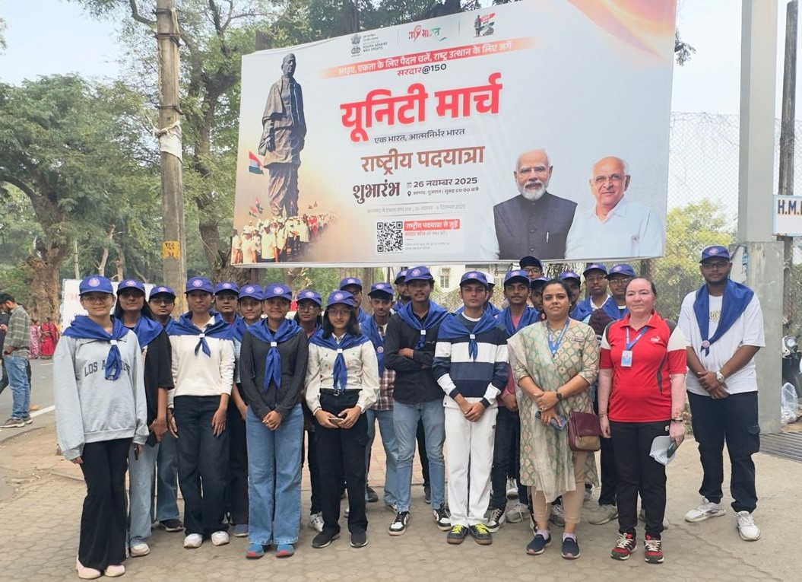
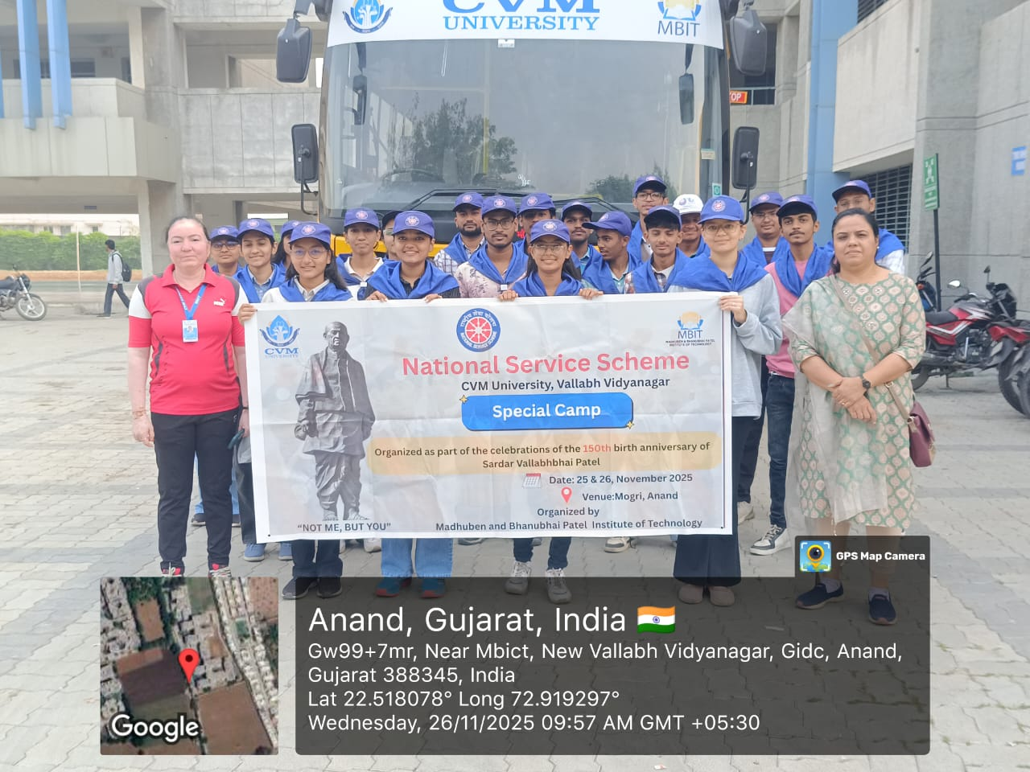
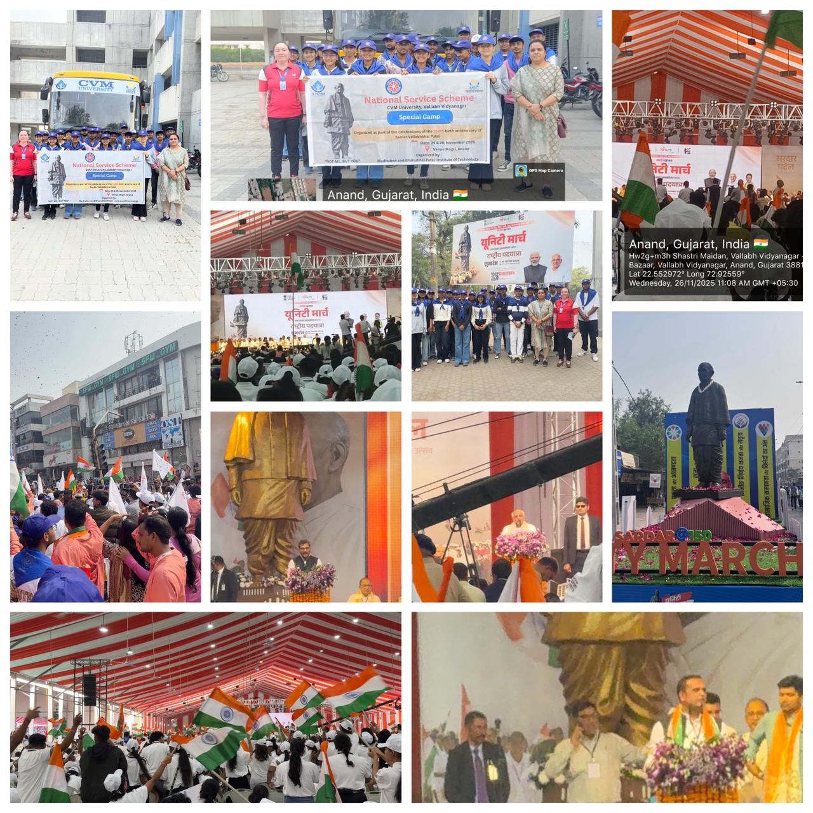

Ms. Khusbu P Patel Dr. Maulika Patel
NSS Program officer Principal, MBIT

