 |  | 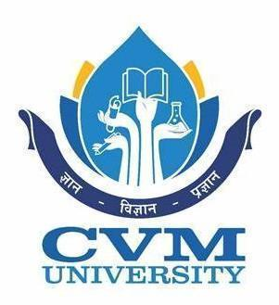
Event Report
Herbal Garden Plantation Program

Date: 15th December 2025
Venue: MBIT Campus
Organized by: NSS Unit, MBIT – CVM University
Report by: Ms. Khusbu P Patel
Coordinator: Ms. Khusbu P Patel (NSS P.O.)

To commemorate the 75th Birth Anniversary of Hon’ble Chairman–CVM and President, CVM University, Er. Bhikhubhai Patel Saheb, the NSS Unit of Madhuben & Bhanubhai Patel Institute of Technology (MBIT) successfully organized a Herbal Garden Plantation Program on 15th December 2025 at the institute campus.
The program aimed at promoting environmental sustainability, creating awareness about medicinal plants, and developing a green and healthy campus environment. On this occasion, saplings of various medicinal and herbal plants such as Tulsi, Satavari, Aparajita, Neem, Lemongrass, Mint, and Ashwagandha were planted within the designated area of the campus to develop a permanent herbal garden.
The plantation activity was graciously carried out by Dr. Amit Ganatra, Dean (R & D), CVM University; Dr. Sandip Valia, Registrar, CVM University; Dr. Arti Papnani, Chairperson, Institute of Engineers, Local Centre, V.V. Nagar; Dr. Maulika Patel, Principal, MBIT; Ms. Khusbu Patel, NSS Programme Officer, MBIT, along with faculty members and enthusiastic NSS volunteers.
All the dignitaries appreciated the initiative taken by the NSS Unit and highlighted the importance of herbal plants in daily life and environmental conservation. NSS volunteers actively participated in planting saplings and took responsibility for their maintenance, thereby reinforcing the spirit of service and social responsibility.
The Herbal Garden Plantation Program was a meaningful tribute to the vision of Hon’ble Chairman–CVM and contributed significantly towards fostering environmental awareness and sustainable practices within the campus.

Glimpses of the event:
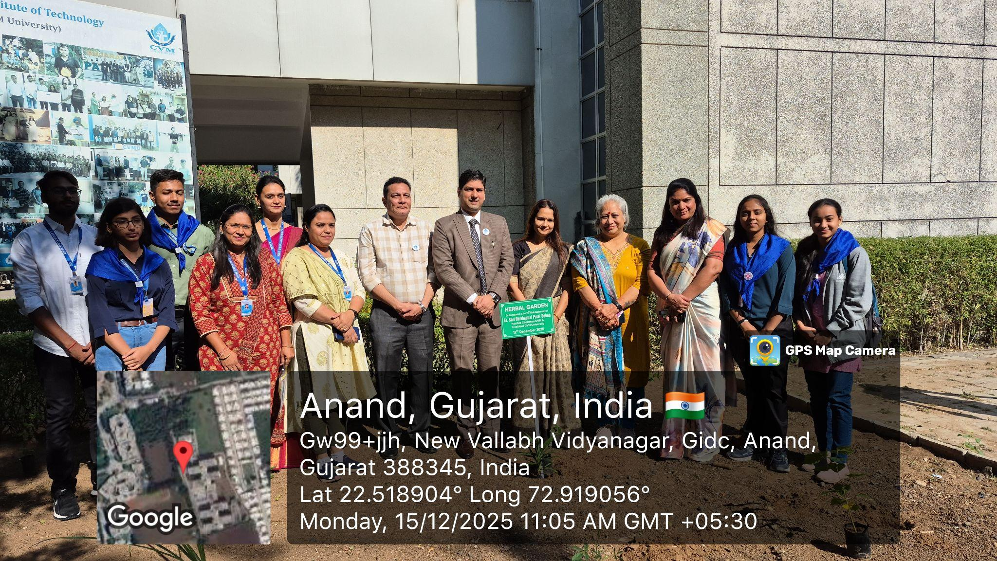
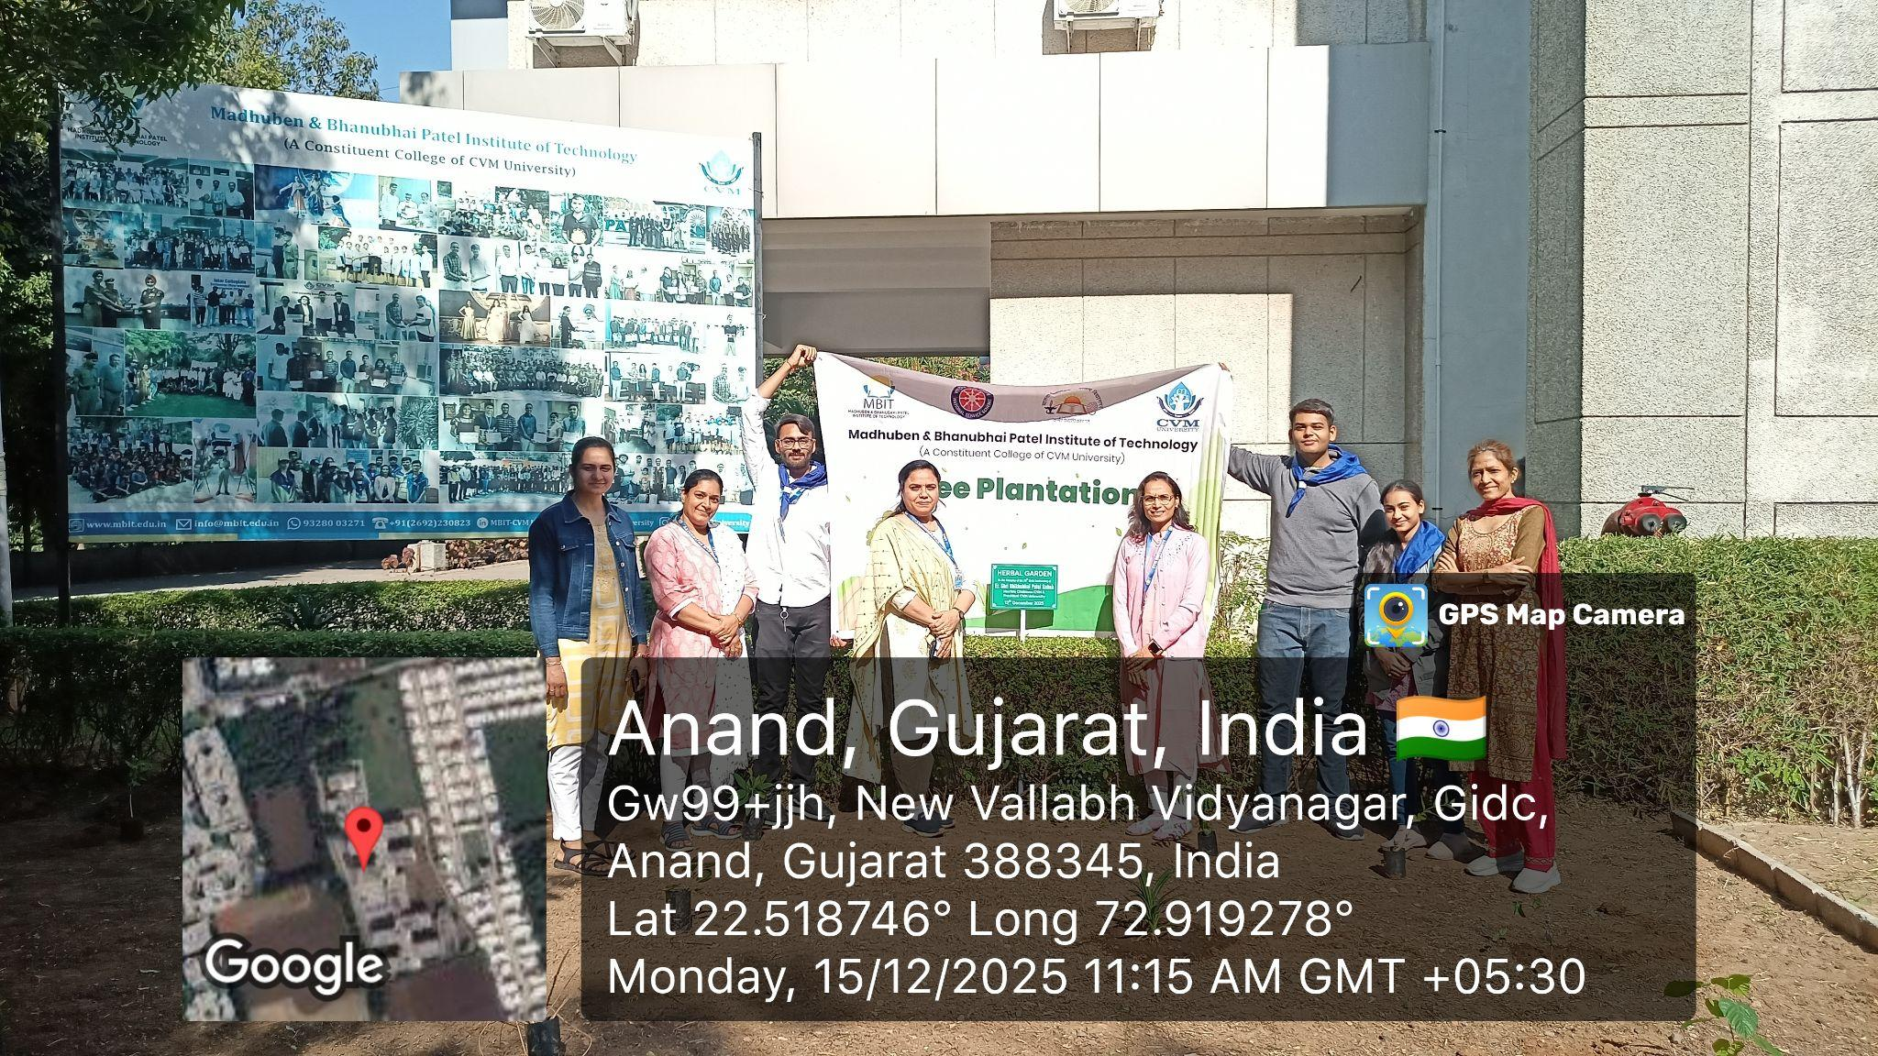
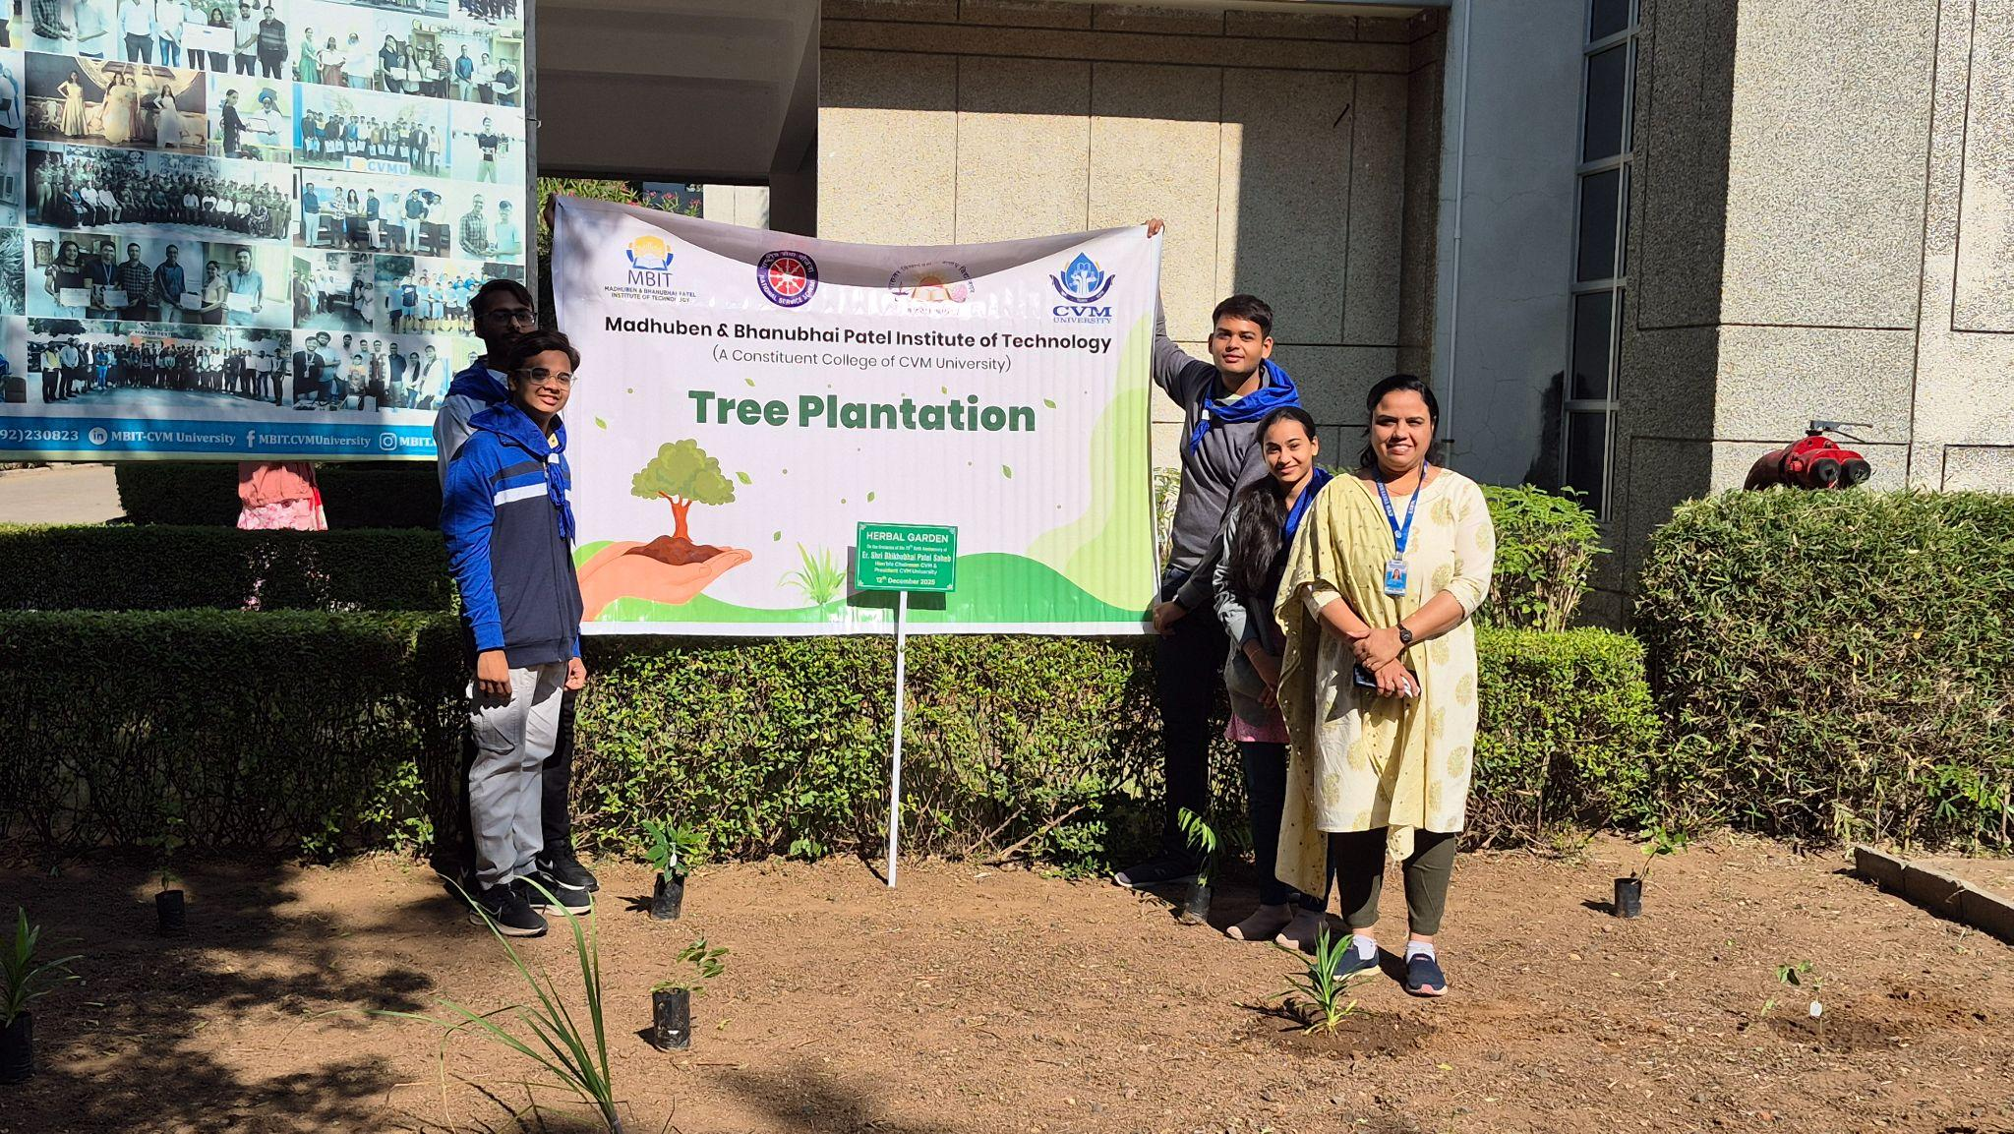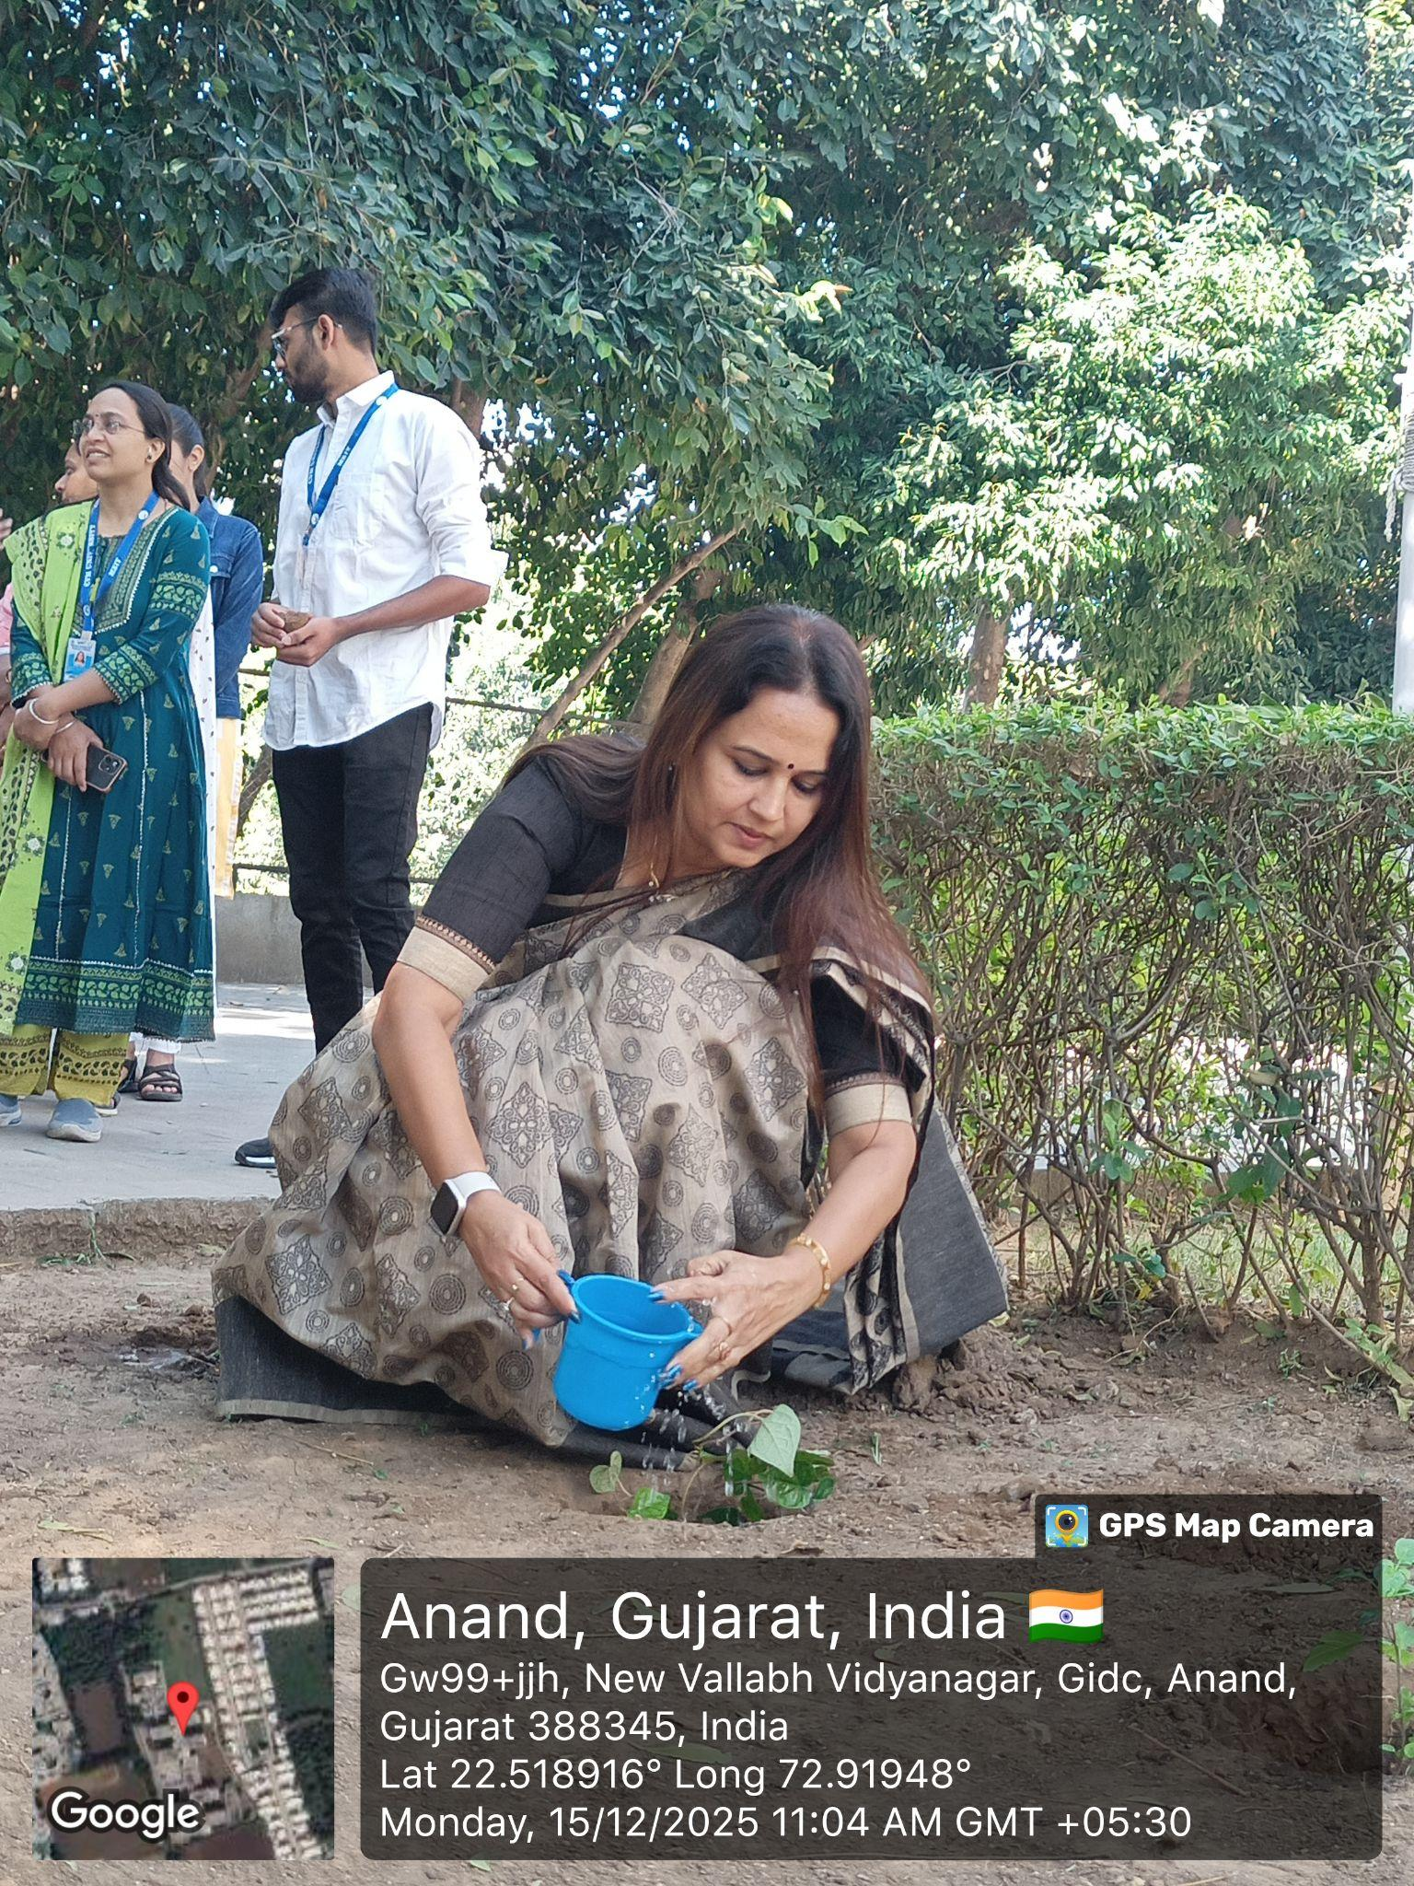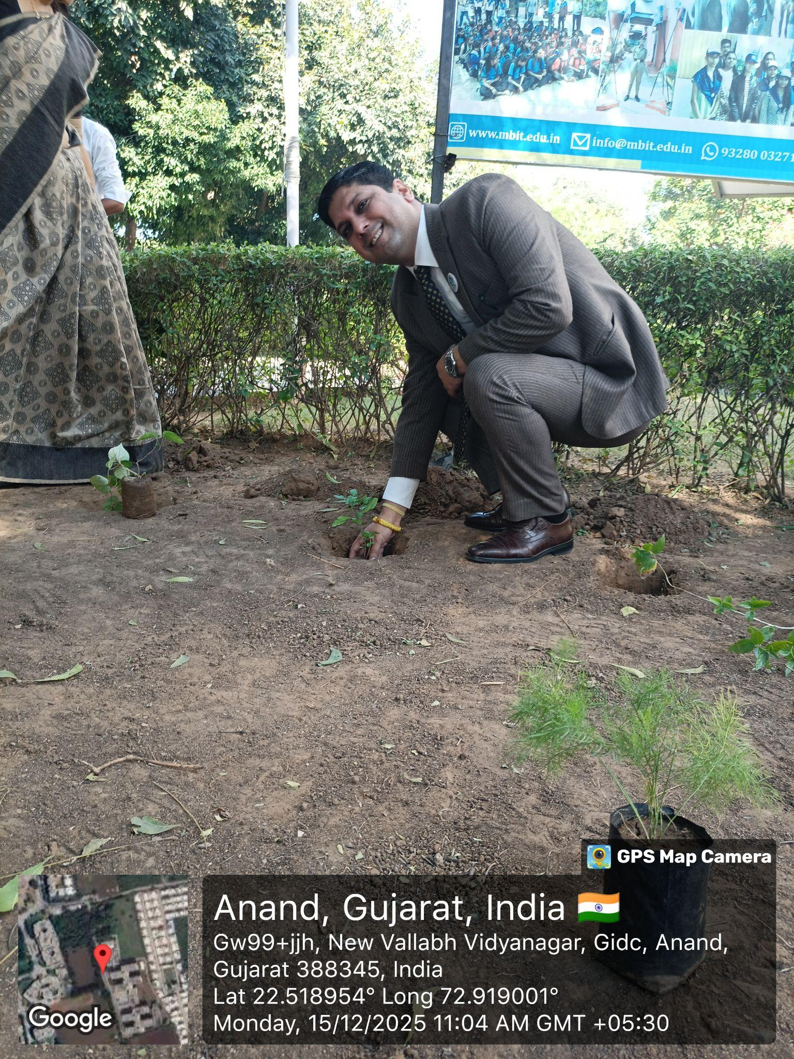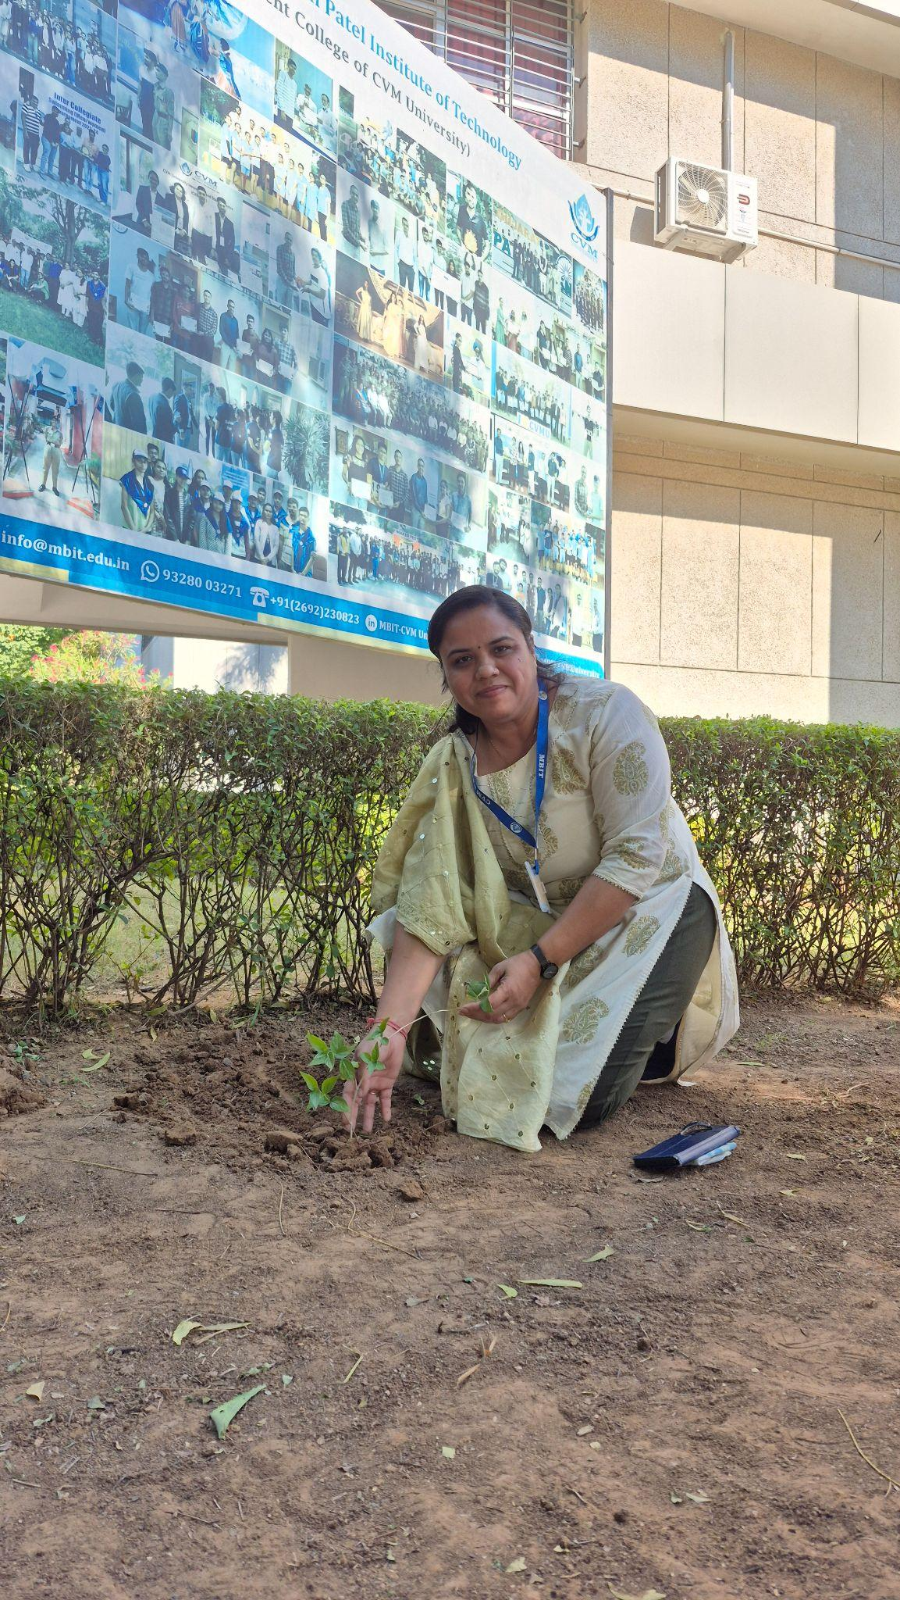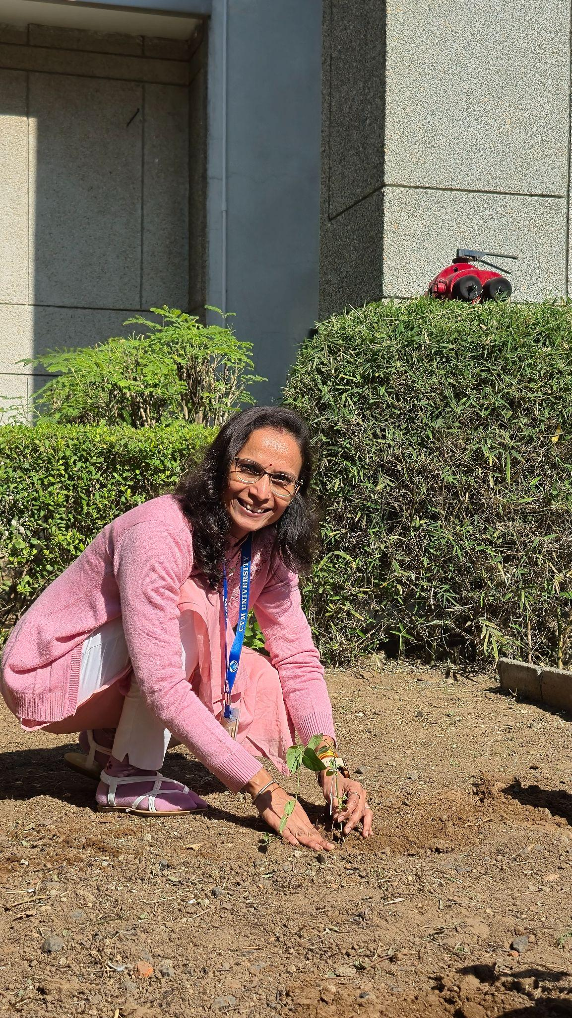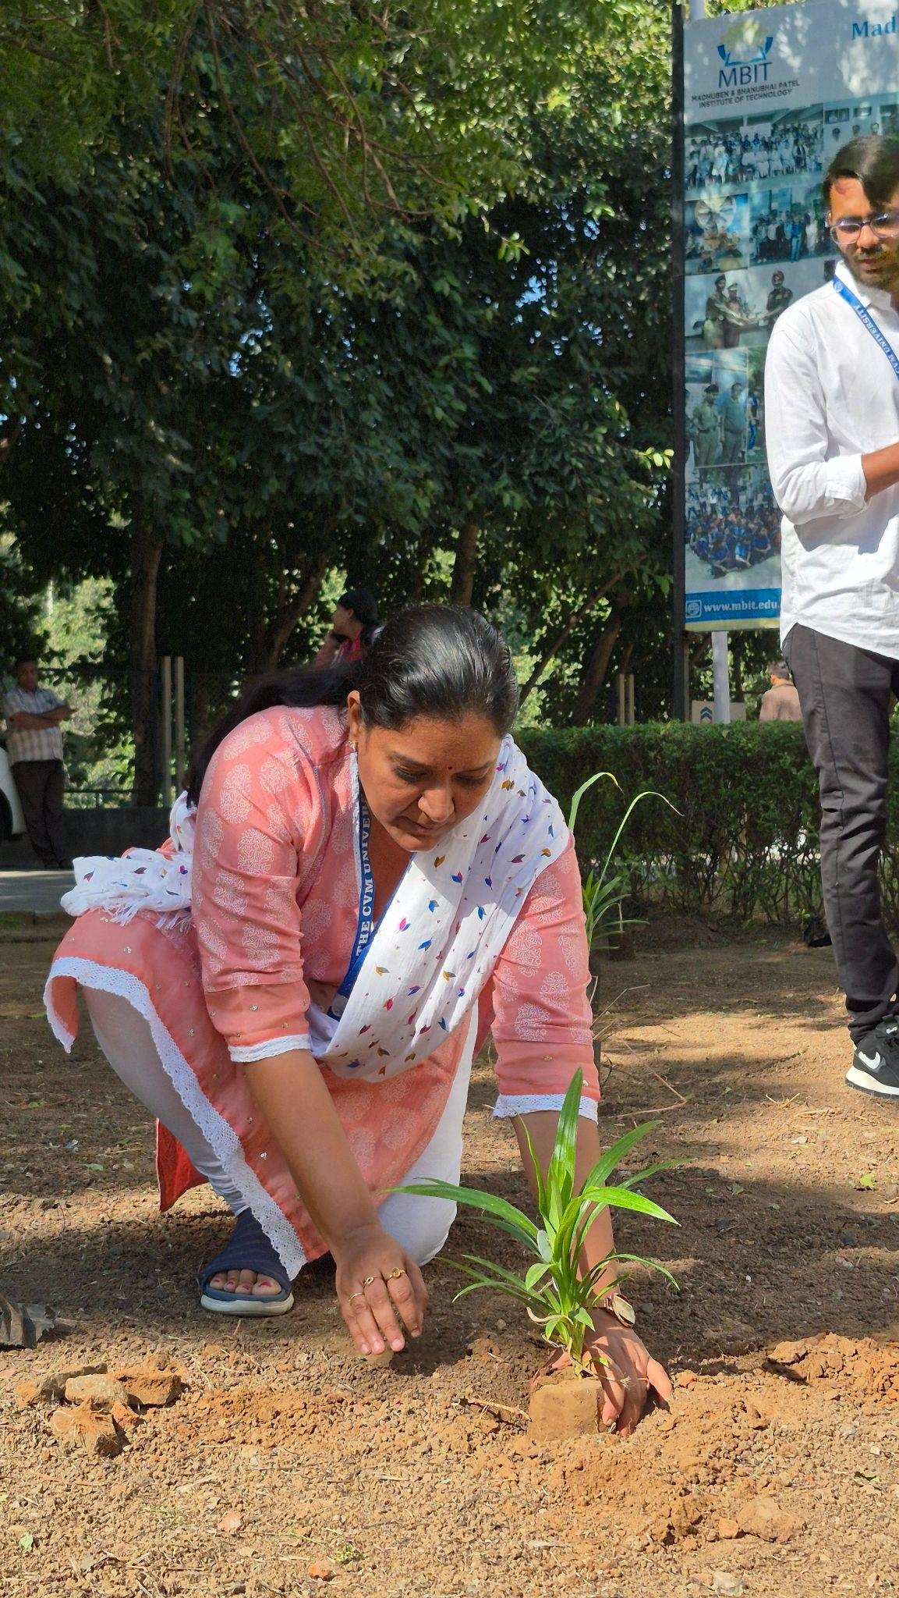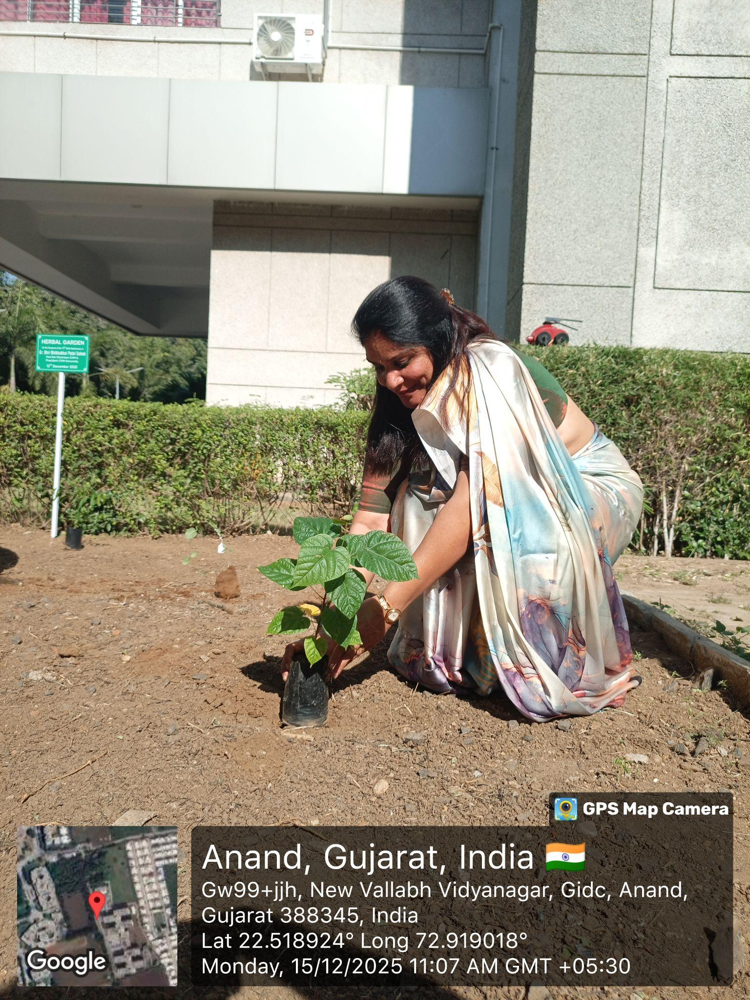

Ms. Khusbu P Patel Dr. Maulika Patel
NSS Program officer Principal, MBIT

